UNIT 7: Capital Expenditure Decision (2)
Semester- VI (UG)
Subject- Financial Management
By- Dr. Sushita Chakraborty
Lecture no-4
Problem-1
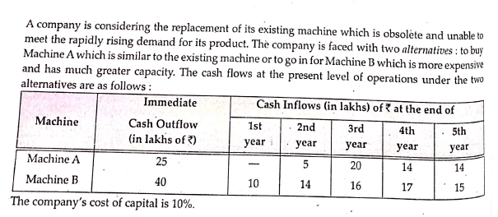
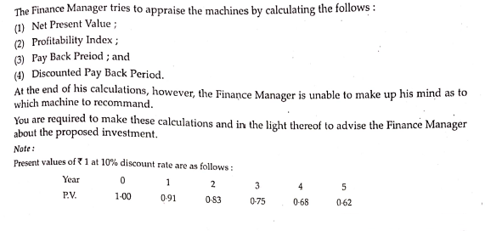

Solution:
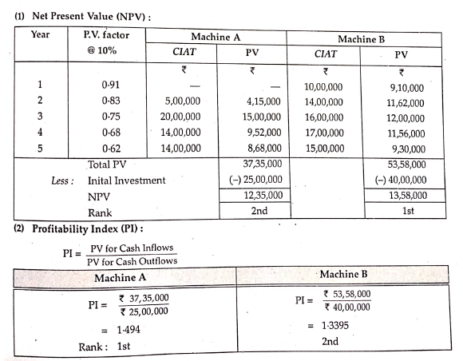

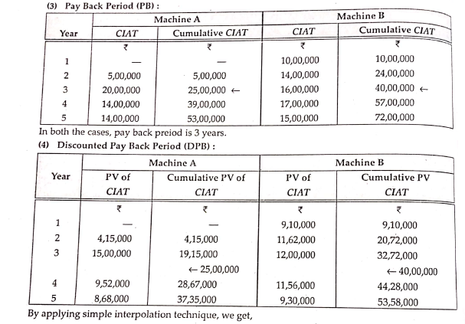
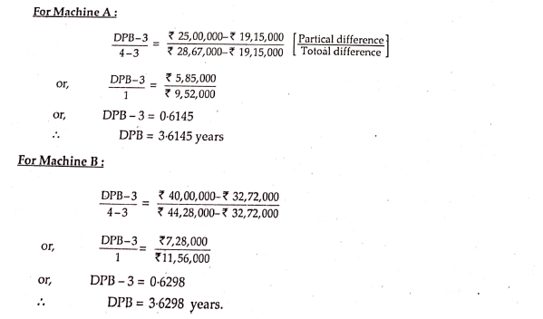

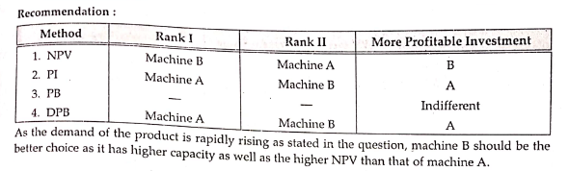
Problem-2
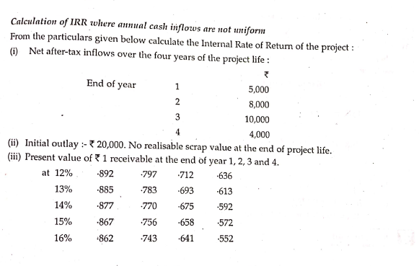
Solution
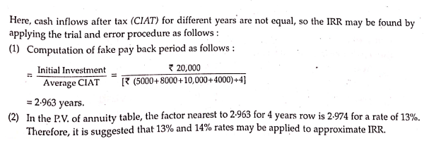

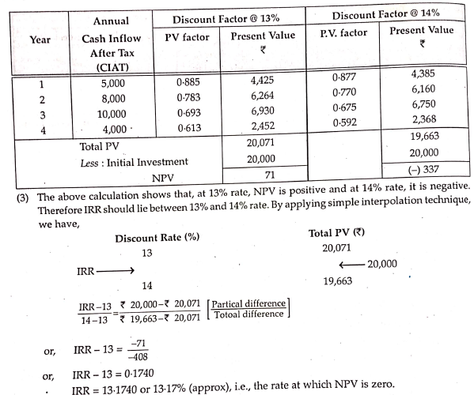

Problem-3
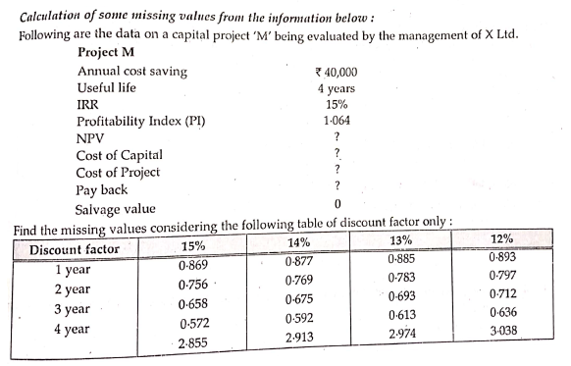
Solution:
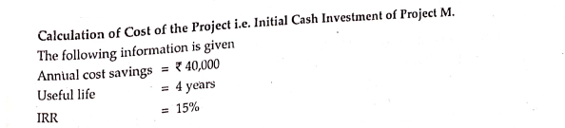
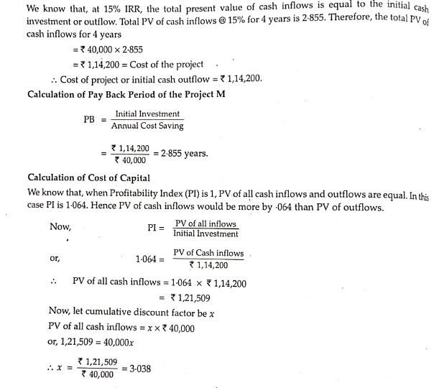
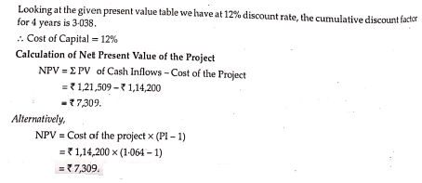

References:
- Dr. D. Mazumder, Dr. S.R. Ali, Dr. L. Nesha -“ An Introduction To Financial Management”.
- Dey, Dutta, Mukherjee -“ A Welcome Approach To Financial Management”.

