UNIT 7: Capital Expenditure Decision (2)
Semester- VI (UG)
Subject- Financial Management
By- Dr. Sushita Chakraborty
Lecture no-2
Problem-1

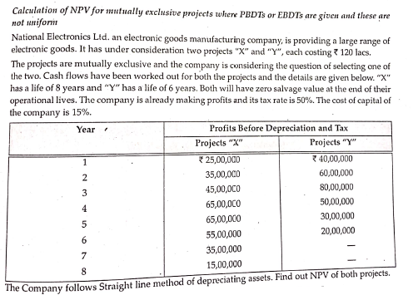
Solution:
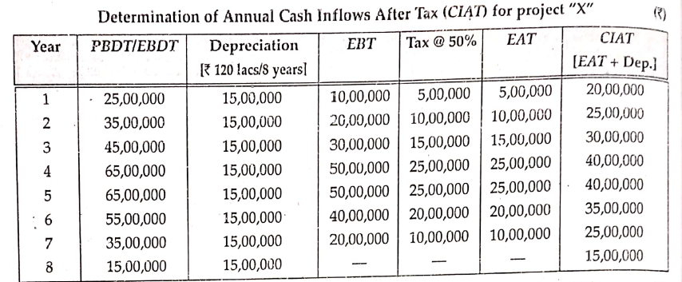

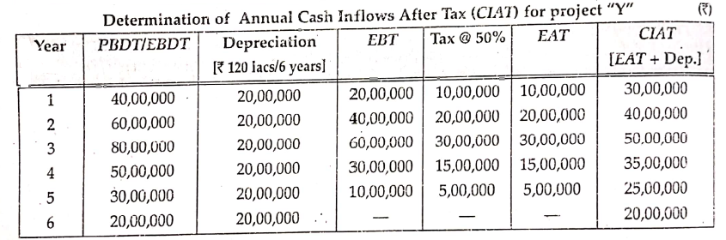
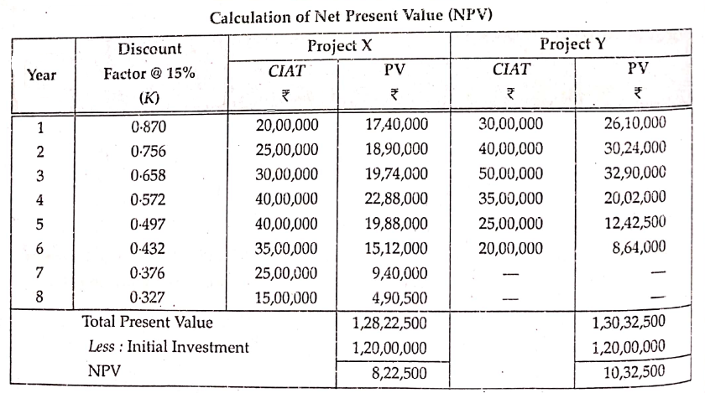

Problem-2
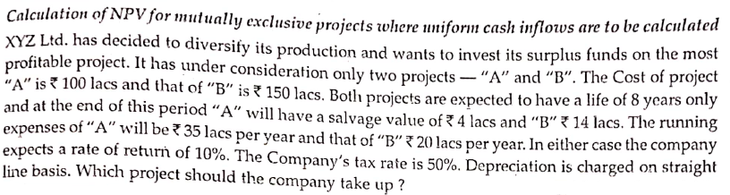

Solution
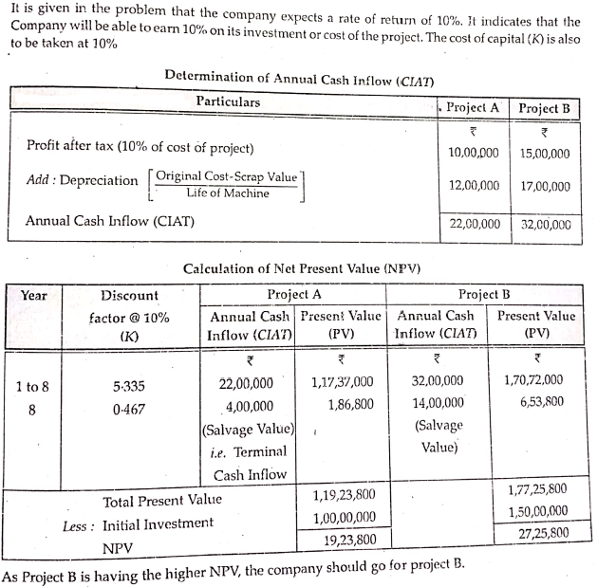

Problem-3
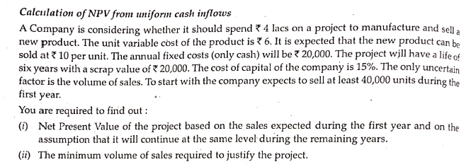
Solution
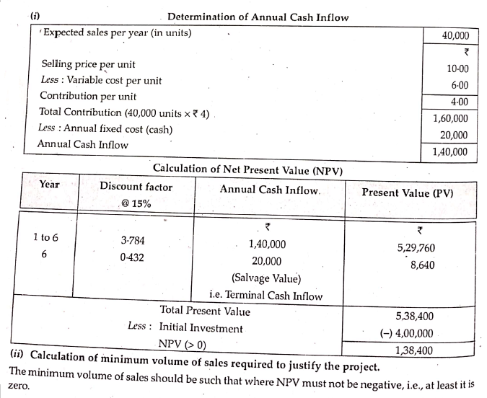
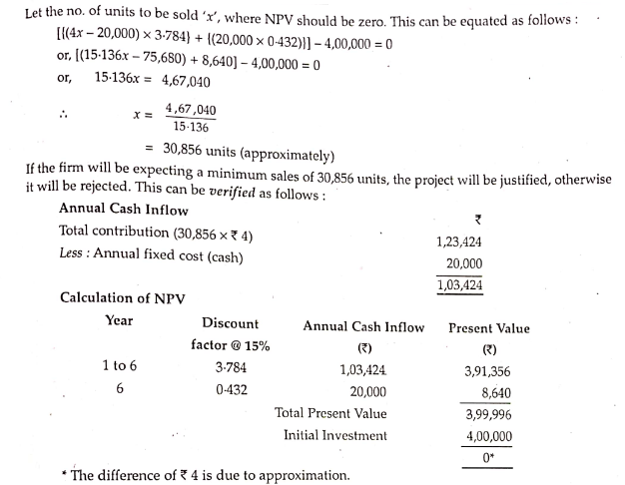

Problem-4
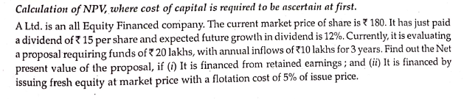

Solution
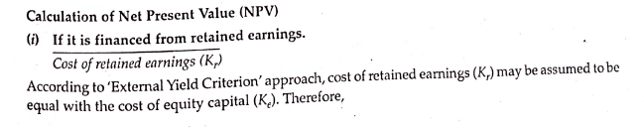
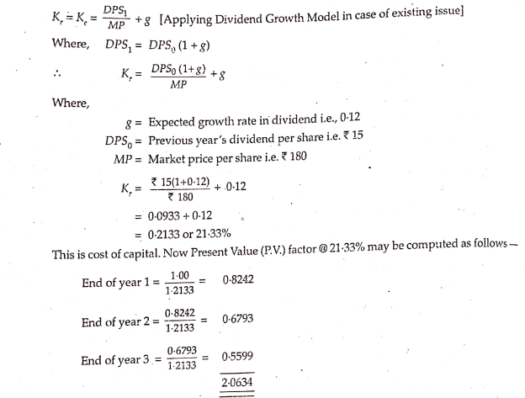
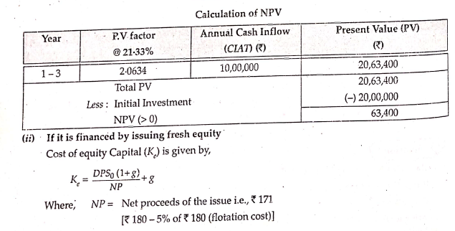
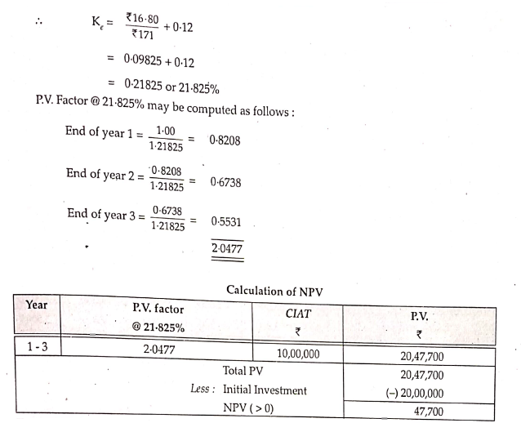

Problem-5
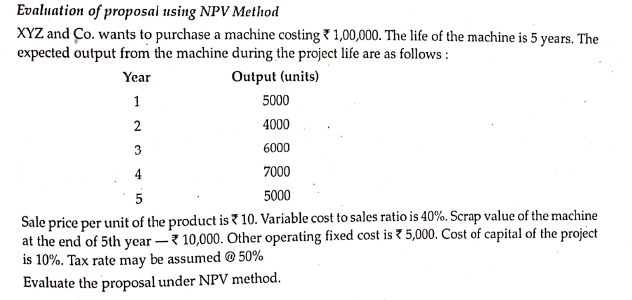

Solution
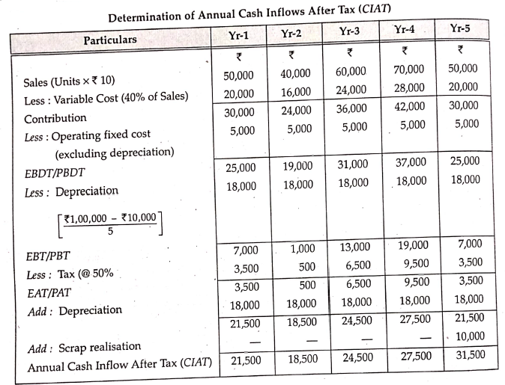
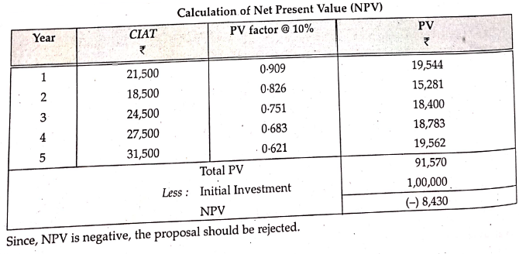

Problem-6
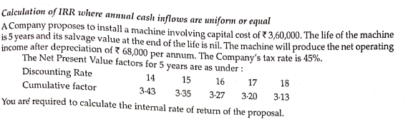
Solution
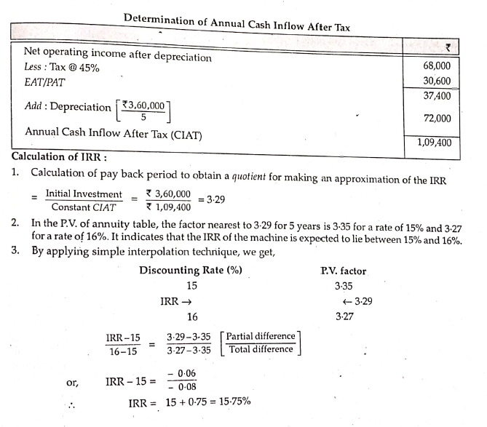

References:
- Dr. D. Mazumder, Dr. S.R. Ali, Dr. L. Nesha -“ An Introduction To Financial Management”.
- Dey, Dutta, Mukherjee -“ A Welcome Approach To Financial Management”.

