UNIT 7: Capital Expenditure Decision (2)
Semester- VI (UG)
Subject- Financial Management
By- Dr. Sushita Chakraborty
Lecture no-1
Problem-1
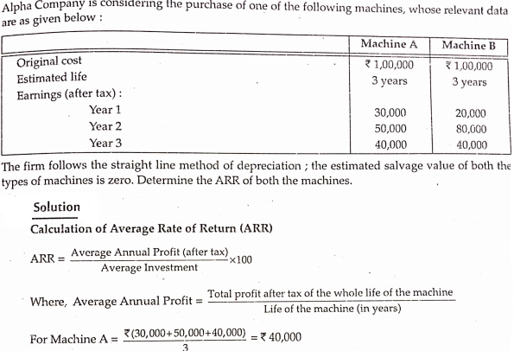
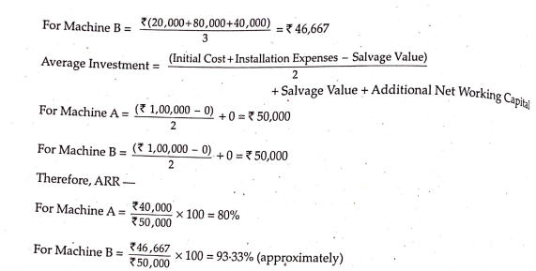

Problem-2
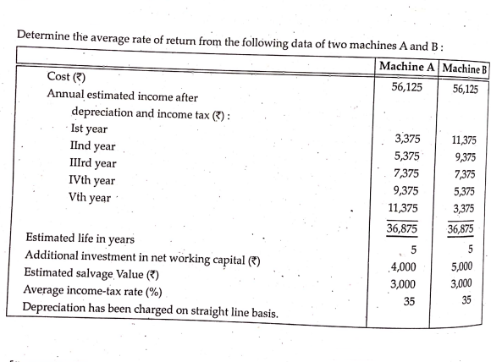
Solution
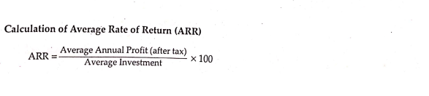
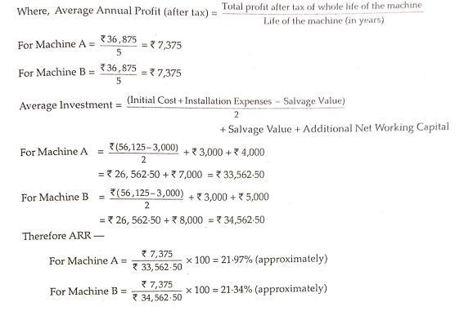
Problem-3
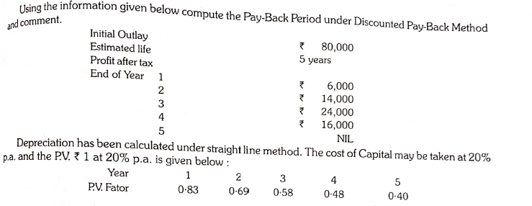
Solution
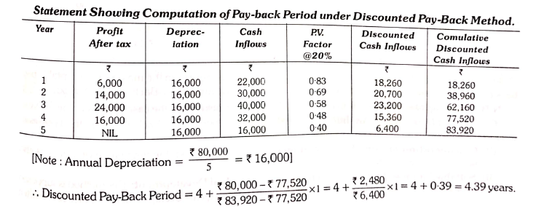

Problem-4
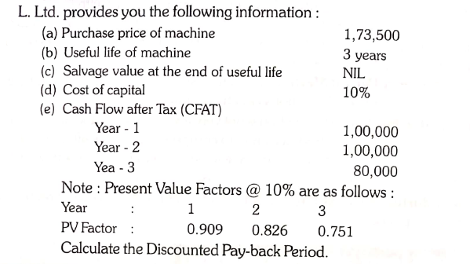

Solution
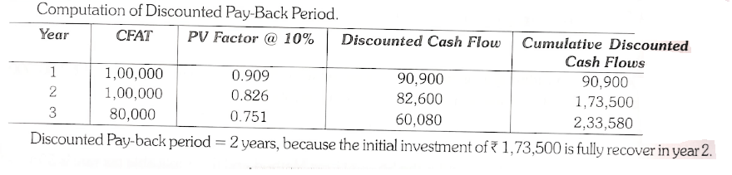

Problem-5
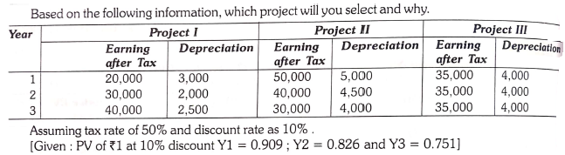
Solution
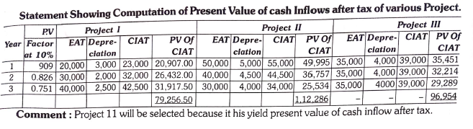

Problem-6
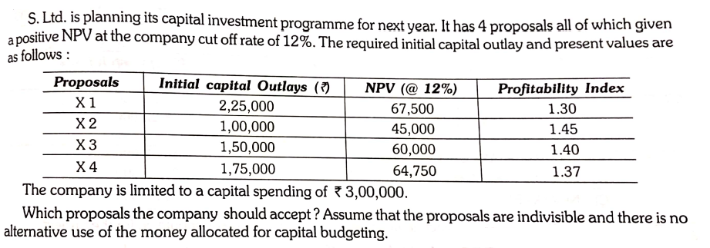
Solution
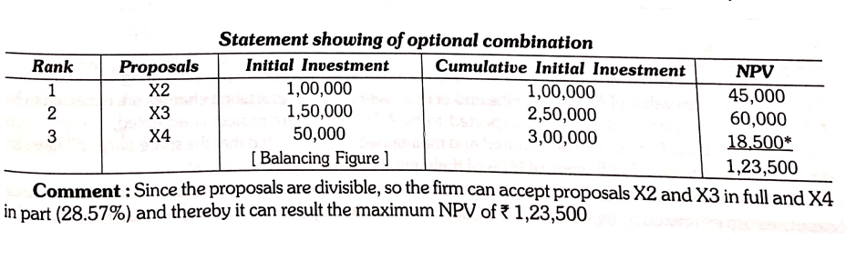
Problem-7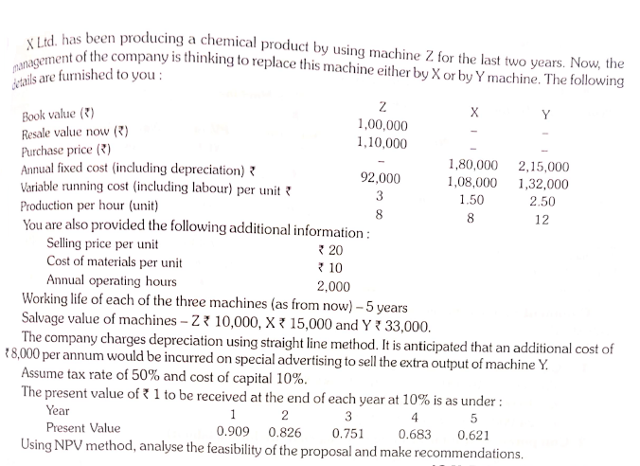

Solution
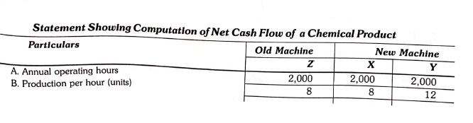
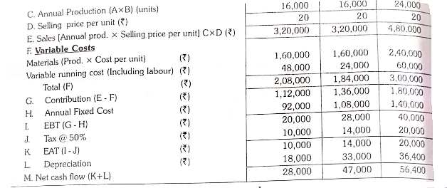

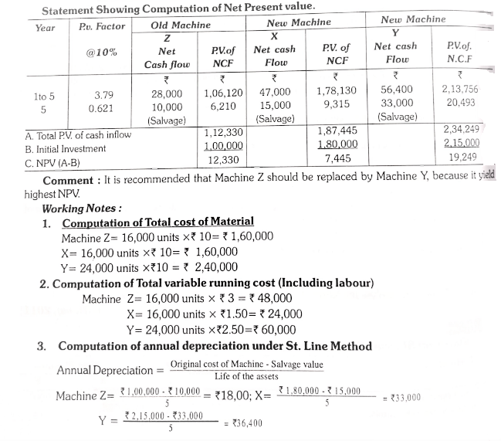

References:
- Dr. D. Mazumder, Dr. S.R. Ali, Dr. L. Nesha -“ An Introduction To Financial Management”.
- Dey, Dutta, Mukherjee -“ An Welcome Approach To Financial Management”.

