UNIT 5: PROMOTION AND RECENT DEVELOPMENTS IN MARKETING
Semester- II (UG)
Subject- Marketing Management
Topic-Direct Marketing and Online Marketing
By- Dr. Sushita Chakraborty
Lecture no-4
Direct Marketing:
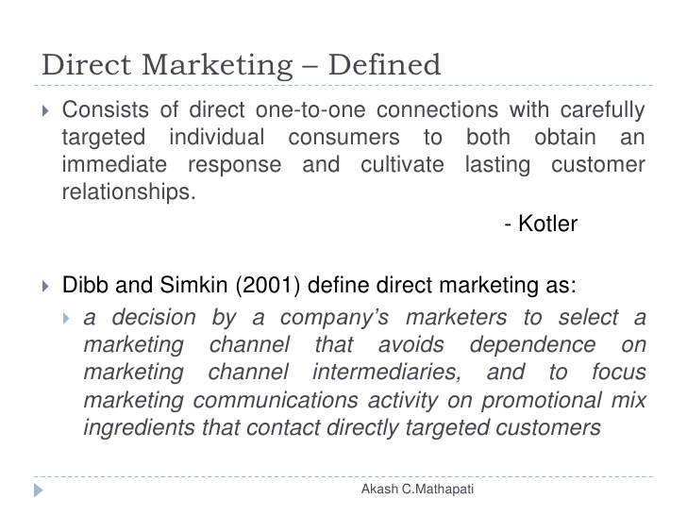
"The primary role of direct marketing is to drive a response and shape the behaviour of target audience with regard to a brand (Kotler and Armstrong, 2009). " Undertaking marketing activity through various advertising media that interact directly with consumers, generally calling for a consumer to make a direct response is known as direct marketing (Kotler and Armstrong, 2009). It is an interactive use of advertising media to stimulate a behaviour modification in such a way that this behaviour can be tracked, analysed and stored on a database for future retrieval and use which is usually built upon to cultivate lasting customer relationships (Stone and Jacob, 2008).
The enhanced competition in all product markets, customer lifestyle, globalisation of markets, internet, and the need to increase manufacturer’s bargaining power are some of the reasons for the growing focus on Direct Marketing.
Direct marketing means connecting directly with carefully targeted segments of individual consumers, often on a one-to-one, interactive basis. For most companies, direct marketing is a supplemental channel, but for others it is a complete way of doing business. Direct marketing is expanding, it is key to the trend towards building close and interactive customer relationships. Direct marketing has certain benefits for buyers: it is convenient, private, easy, hassle-free, time saving and gives a lot of comparative information. It also has benefits for sellers: it is an important tool for building customer relationships and is a low-cost and efficient way of reaching target markets. Direct marketing begins with a good customer database. Direct Marketing connecting directly with carefully targeted individual consumers to both obtain an immediate response and cultivate lasting customer relationships. Direct Marketing is an interactive mode of marketing through which the marketer reaches out to his target market, at any location. Direct Marketing helps companies to focus their marketing efforts and, hence, to that effect is more focused and targeted than conventional or general marketing. Teleshopping, home shopping channels, catalogue marketing, and online shopping are some of the tools that enables companies to carter to this core customer value. Therefore, database marketing is an interactive approach to marketing, using all available communication tools and media vehicles to reach to the target market.
The direct-marketing industry has been facing some privacy concerns and cases of unfair practices. Direct marketing can sometimes annoy customers. Internet fraud has become a serious problem. Phishing, a type of online identity theft uses deceptive emails to fool users into divulging their personal data. Customers also worry about online security and their privacy. Many online marketers have become skilled at obtaining detailed consumer information. Because of these challenges, various governments are putting up legislation to protect customers.

Direct marketing has passed through a number of stages:
- Carpet Bombing:
Direct mailers gather or buy as many names as possible and send out a mass-mailing. Usually the response rate is very low.
- Database Marketing:
Direct marketers mine the database to identify the prospects who would have the most interest in an offer.
- Interactive Marketing:
Direct marketers include their telephone number and Web address, and offer to print coupons from the Web site. Recipients can contact the company with questions. The company uses the interaction as an opportunity to up-sell, cross-sell, and deepen the relationship.
- Real-time personalised Marketing:
Direct marketers know enough about each customer to customize and personalize the offer and message.
- Lifetime value Marketing:
Direct marketers develop a plan for lifetime marketing to each valuable customer, based on knowledge of life events and transitions.

Features of Direct Marketing:

No middlemen

Customer oriented

Direct channel

Direct contact

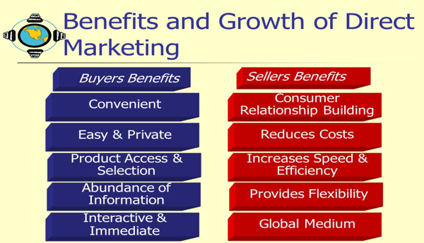

Forms of Direct Marketing
A customer database is an organised collection of comprehensive data about individual customers or prospects, including geographic, demographic, psychographic and behavioural data. Companies can use this database to located potential customers, learn about their customers and build relationships with them. There are several major forms of direct marketing.

Direct mail and catalogue marketing Direct mail marketing:
Defining direct mail marketing, Kotler and Armstrong say, "Direct-mail marketing through single mailings that include letters, ads, samples, foldouts and others sales people on wings sent to prospect on mailing lists." Direct – mail marketing involves sending an offer, announcement, reminder, or other item to a person at a particular physical or virtual address.
Direct-mail marketing: Direct marketing by sending an offer, announcement, reminder or other item to a person at a particular physical or virtual address. It can be used well for direct one-to-one communication, but can be resented as “junk mail”.

Catalogue marketing:
Defining catalogue marketing Kotler and Armstrong have said, "Direct marketing through catalogue that are mailed to select list of customers or made available in stores." Catalogue marketing is Direct Marketing through print, video, or digital catalogues that are mailed to select customers, made available in stores, or presented online.
Catalogue marketing: direct marketing through print, video or digital catalogues that are mailed to select customers, made available in stores, or presented online. They eliminate mailing costs and allow for real-time merchandising.

Telemarketing
Defining telemarketing, Kotler and Armstrong have said, "Using the telephone to sell directly to customers is telemarketing." Association of Telemarketing has said, "We want to target people who want to be targeted."
Telephone marketing: Using the telephone to sell directly to customers. However, the recent do-not-call rules have been hurting the telemarketing industry. In fact, companies carry out four types of telemarketing:
- Telesales
- Telecoverage
- Teleprospecting
- Customer service and technical support.
Direct-response television (DRTV) marketing: Direct marketing via television, including direct-response television advertising (or infomercials) and home shopping channels. Home-shopping channels are television programmes or channels dedicated to selling goods and services.
Kiosk marketing is marketing via information and ordering machines. As consumers become more and more comfortable with computer and digital technologies, many companies are placing information and ordering machines-called kiosks in stores, airports, and other locations. Kiosks are popping up everywhere these days, from self-service hotel and airline check-in devices to in-store ordering kiosks that let the order of the consumer merchandise not carried in the store.
New digital direct-marketing technologies such as mobile phone marketing, podcasts /vodcasts and interactive TV are upcoming tools.
Three aspects of Direct Marketing – interactive system, measurability of response, and not location specific.
Marketing mix in the direct marketing mode remains the same by and large, except for the communication programme, customer service, and timing and sequence which require considerable attention.

Online shopping
Defining online shopping, Kotler and Armstrong have said, "Shopping through interactive online computers services, two-way system that link consumers with sellers electronically."
Online marketing are efforts to market products and service and build customer relationships over the internet. The Internet is a vast public web of computer networks that connects users of all types around the world to each other and an amazingly large information repository. Click-only companies are the so-called dot-coms, which operate only online and have no brick-and-mortar market presence. Click-and-mortar companies are traditional brick-and-mortar companies that have added online marketing to their operations. There are four major online marketing domains.
- Business-to-consumer (B-to-C) online marketing: Businesses selling goods and services online to final consumers.
- Business-to-business (B-to-B) online marketing: Businesses using online marketing to reach new business customers serve current customers more effectively and obtain buying efficiencies and better prices.

- Consumer-to-consumer (C-to-C) online marketing: Online exchanges of goods and information between final consumers. Blogs are online journal where people post their thoughts, usually on a narrowly defined topic. Companies can also advertise on blogs and influence content there.
- Consumer-to-business (C-to-B) online marketing: Online exchanges in which consumers search out sellers, learn about their offers and initiate purchases, sometimes even driving transaction terms.

Either way, most companies now exist online. Corporate (brand) websites are websites designed to build customer goodwill, collect customer feedback and supplement other sales channels rather than sell the company’s products directly. A marketing website is a website that engages consumers in interactions that will move them closer to a direct purchase or other marketing outcome. However, creating a website is not enough, sites must be visited and therefor a website must be promoted. This can be done via online advertising: Advertising that appears while consumers are browsing the Web, including display ads, search-related ads, online classifieds and other forms. Rich media allow animation, sound, video and interactivity. The largest form of online advertising is search-related ads (or contextual advertising). Viral marketing is the Internet version of word-of-mouth marketing: websites, videos, email messages or other marketing events that are so infectious that customers will want to pass them along to friends.
Online social networks: online social communities, blogs, social networking websites or even virtual worlds, where people socialise or exchange information and opinions. Marketers can engage in online social networks by participating in existing Web communities or establishing their own. Social networking sites presents challenges, since companies do not really know how to use them effectively. E-mail is an important and growing online marketing tool and it can be the ultimate marketing medium. However, the explosion of spam (unsolicited, unwanted commercial e-mail messages) can lead to customer irritation.
References:
- Philip Kotler-“ Marketing Management”(2003, eleventh edition)
- Rajan Saxena-“Marketing Management”( 2009, Fourth edition)
- V S Ramaswamy and S Namakumari-“ Marketing Management -Planning, Implementation and Control”. ( 2009, Fourth edition).
- Philip Kotler, Gary Armstrong ,Prafulla Y. Agnihotri, Ehsan ul Haque, Kevin Lane Keller, Abraham Koshy, Mithileshwar Jha, “Marketing Management – for IMT, Ghaziabad”

