B.COM: SEM--4
Subject: ENTREPRENEURSHIP EVELOPMENT
UNIT -II
TEACHER: DR B.CHANDRA
LECTURE NO. 03
TOPIC : Role of self-help groups,

Concept:
A self-help group, abbreviated as (SHG) is a village-based financial intermediary committee normally consist of 10–20 local women or men. Self-help group is basically group of individual members who by free alliance come together for a common communal purpose. Practically, self-help group include individual members recognized to each other and belong to the same village, community and even marketing area. They are homogeneous and have certain pre group social binding factors. In the context of micro-finance, self-help group are made around the theme of investments and credit.
Most self-help groups are situated in India but these groups are also found in other countries, particularly in South Asia and Southeast Asia. Self-help group are unique and pioneering organizational establishment in India for the enhancement of women and welfare. All women in India are encouraged to join any one of SHGs for training and development, so as to become potential entrepreneur and skilled worker. Self-help group are promoted by the Government as if women in India may not be ingenious enough to be entrepreneurs. When the Self-help group arrange training facilities to perform certain task which are suitable for women in India, bank must provide financial support to carry out manufacturing and business operations, arranging marketing facilities while the Governments will procure the product of SHGs, arrange for enhancing the capacity of women in terms of leadership quality and arranging for the management of SHGs by themselves so as to have administrative capacity. As a social movement with government support, Self-help group become effective for the society
The Self Help Groups Guiding Principle emphasizes on organizing the rural poor into small groups through a process of social mobilization, training and providing bank credit and government subsidy. Self-help group are to be drawn from the BPL list permitted by the Gram Sabha in which about ten persons are selected one each from a family and focus on the skill development training based on the local requirement. Self-help group movement has gathered pace in country and is directly or indirectly supporting towards the monetary development of countryside areas.

Self help group mechanism
In literature, a self help group is described as a group comprised of people who have personal experience of an analogous issue or life situation, either directly or through their family and friends. People who share experiences facilitate them to give each other a unique quality of mutual support and to pool practical information and ways of coping. Self help groups are small informal association of the poor formed at the grass root level for the purpose of enabling members to reap economic benefits out of mutual help solidarity and joint accountability. Self help groups are developed willingly by the rural and urban poor to contribute to a common fund to be lent to its members as per group decision and for working together for social and economic uplift of their families and community.
Other experts explained self help group as a “self-governed, peer controlled information group of people with similar socio-economic background and having a desire to jointly perform common purpose." According to The Tamil Nadu Corporation for Development of Women Ltd. (TNCDW), “self help group is a small economically homogenous affinity group of rural poor, voluntarily formed to save and contribute to a common fund to be lent to its members as per group decision and for working together for social and economic uplift of their family and community".
Mission of self help group:
1. To promote saving amongst the poor women of country.
2. To help the poor, realize their entrepreneurial and business management skills through training and access to capital.
Major objective of SHG is to augment the economic development of women and create supportive environment for their social transformation in the lift of gender discrimination in work and the household. Other purpose of the self help group is to build the functional capacity of the poor and the marginalized in the field of employment and income generating activities.
Objectives of selp help group
1. To promote saving and teach financial management skills.
2. To improve access to saving and credit services.
3. To improve living standards.
4. To reduce vulnerability to poverty in times of crisis (sickness, death etc)
5. To further economic self-reliance.
6. To encourage community coherence.
7. To offer a forum for the sharing of ideas and knowledge.
8. To provide support for members in difficulty.
9. To help the community in identifying and resolving their own problems.
Self help group are small and economically homogenous resemblance groups of rural poor, they voluntarily join to accomplish the following task.
1. To save small amount of money regularly.
2. To mutually agree to contribute a common fund.
3. To fulfil their emergency requirements.
4. To have joint decision making.
5. To solve clashes through collective leadership mutual discussion.
6. To provide security free loan with terms decided by the group at the market driven rates.
Self help groups have also amalgamated into big organizations. Typically, about 15 to 50 SHGs make up a Cluster / voluntary organization with either one or two representatives from each SHG. Depending on geography, several clusters come together to establish an apex body or an SHG Federation. It can be illustrated by following figure:
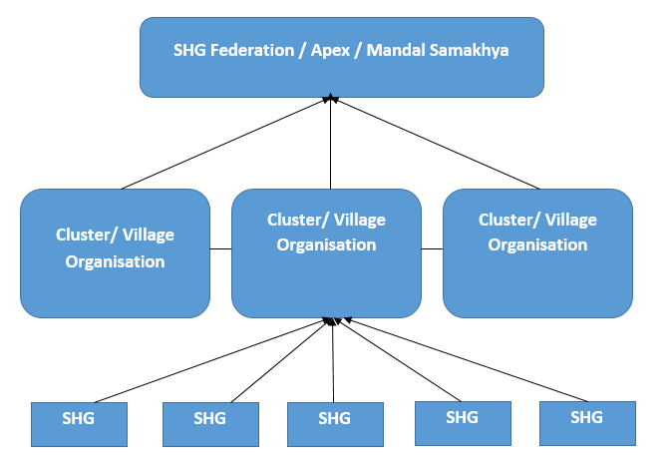

Features of a good Self Help Group:
Well organized self help group should have following structural features:
• Perfect self help group comprises 15-20 members
• All the members should belong to the same socio-economic strata of society specifically poor.
• Group should have strong bond of sympathy.
• Rotational leadership should be encouraged for allocation of power and to provide leadership opportunities to all the members.
• Members should attend meetings, save and participate in all activities voluntarily.
• Aim must be to provide gainful employment and to involve the poor in productive activities.
• Self help group should be socially feasible institution.
• The procedure of decision-making in Self help group should be self-governing in nature.
• It should be non-partisan in nature.
• The group frame rules and regulations which are necessary for its effective functioning.
• Self help group must involve women in decision making and to promote leadership qualities among them.
• It promotes objectives like economic improvement and raising resources for development and freedom from exploitation.
• The form of such a group could be mostly on an informal basis.
Requirement and significance of self help group in India:
Self help groups are mainly formed to eradicate exploitation, generate confidence for the economic independence of rural people, particularly among women who are mostly imperceptible in society. These groups facilitate them to join together for common objective and gain strength from each other to deal with exploitation, which they are facing in several forms. A group become the basis for action and change. It also assists to develop relationship for mutual trust between the promoting organization and the rural poor through continuous contact and genuine efforts.
Self help groups has vital role in distinguishing between consumer credit and production credit, appraising the credit system for its implication and changes in economy, culture and social position of the target groups, providing trouble-free access to credit and assisting group/organization for effective control, ensuring repayments and continuity through group dynamics; establishing visible norms for interest rates, repayment schedules, development period, extension, writing of bad debts; and assisting group members in getting access to the formal credit institutions. Consequently, self help group distributes microcredit to the rural women for the purpose of making them enterprising women and encouraging them to enter into commercial activities. Credit needs of the rural and urban poor women are fulfilled totally through the SHGs. SHGs augment impartiality of status of women as participation, decision-makers and beneficiaries in the democratic, economic, social and cultural spheres of life.
In rural areas, people are not competent to fulfil their basic requirement because most of them are socially backward, uneducated, with low motivation and poor economic base. They also lack access to the knowledge and information, which are the most important mechanism of development process in present scenario. It has been realized by experts that in group, they may develop strength to overcome many of these weaknesses. Self help group is formed to meet the requirement of people which are as under:
• To mobilize the resources of the individual members for their collective economic development.
• To uplift the living conditions of the poor.
• To create a habit of savings, utilization of local resources.
• To mobilize individual skills for group's interest.
• To create awareness about right.
• To assist the members financial requirement at the time of necessity.
Entrepreneurship development:
• To identify problems, analysing and finding solutions in the groups.
• To act as a media for socio-economic development of village.
• To develop linkage with institution of NGOs.
• To organize training for skill development.
• To help in recovery of loans.
• To gain mutual understanding, develop trust and self-confidence.
• To build up teamwork.
• To develop leadership qualities.
• To use it as an effective delivery channel for rural credit
Major functions of self help group :
The important functions of SHG are as under:
i. Facilitating members to become self-reliant and self-dependent.
ii. Providing a forum for members for discussing their social and economic problems.
iii. Enhancing the social status of members by virtue of their being members of the group.
iv. Providing a platform for members for exchange of idea.
v. Developing and encouraging the decision making capacity of members.
vi. Fostering a spirit of mutual help and cooperation among members.
vii. Instilling in members a sense of strength and confidence which they need for solving their problems.
viii. Providing organizational strength to members.
ix. Providing literacy and increasing general awareness among members.
x. Promoting numerically and equipping the poor with basic skills required for understanding monetary transactions.
Code of Conduct and Self help group Mechanism:
Self help group is a registered or unregistered group of micro entrepreneurs having homogeneous social and economic background, voluntarily coming together to save small amount regularly, to contribute a common fund and to meet their emergency needs on mutual help basis. Code of conduct for self help group is well established. Group members will:
1. Respect the role of the group facilitator
2. Demonstrate respect for each other
3. Be courteous to others at all times
4. Listen to each other
5. Allow others to speak and have their say
6. Take time out if needed
7. Keep to time
8. Abide by the group rules on confidentiality and unacceptable behaviour
9. Refrain from using offensive language
10. Refrain from using sexist or racist comments or behaviour
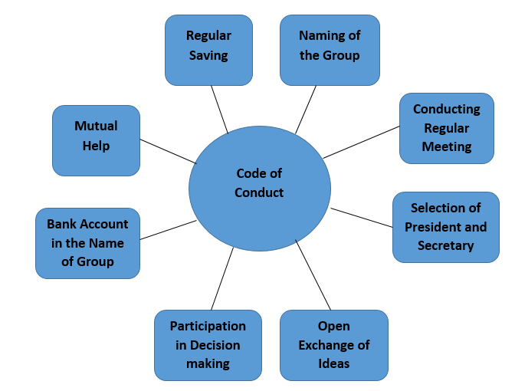

Self help group is an effective tool to women empowerment:
It has been well recognized that any nation can progress if there is social and economic enhancement of females of that country. Empowerment by way of participation in Self-help group can bring desirable changes and augmentation in the living conditions of women in poor and developing nations. Through self-help group, large group of women (10 - 20), with common objectives participate in the development activities such as saving, credit and income generation thereby ensuring economic independence. Self-help group phenomenon definitely brings group consciousness among women, sense of belongingness and adequate self-confidence. Self-respect and fulfillment in life expands and augments the quality of status of women as participants, decision makers and beneficiaries in the self-governing economic social and cultural spheres of life. It can be said that Self-help group is an effectual tool to empower women socially and economically which finally contributes in the all-round development of the country.
To summarize, Self-help group is process of organising the poor populace of village areas and the marginalized to join together to solve their personal problem. The self-help group method is used by the government, NGOs and others at global scale. In India, Self-help groups have gained success in bringing the women to the main stream of decision making. Self-help groups have become a source of inspiration for women’s welfare. Formation of SHG is a feasible alternative to attain the objectives of rural development and to get community contribution in all rural development programmes. Self-help group is also a practicable organized set up to disburse micro credit to the rural women and encouraging them together into entrepreneurial activities (Abdul, 2007). To lessen the poverty and to empower the women, the micro-finance, Self-Help Groups (SHGs) and credit management groups have also started in India.
=====================================================================================

