B.COM: SEM--2
Subject: CMA I
TEACHER: DR D.BAIDYA
LECTURE NO. 01

Cost Sheet: Meaning, Objects and Method of Preparation
1. Meaning of Cost Sheet
2. Objects of Preparing a Cost Sheet
3. Method of Preparation.

Meaning of Cost Sheet:
Cost Sheet is a statement which presents detailed information relating to the various stages of cost. It also shows the total cost of the product manufactured during a particular period of time. Thus, the cost sheet is prepared for a particular period of time monthly, quarterly, yearly etc.

Objects of Preparing a Cost Sheet:
A cost sheet is prepared for:
ADVERTISEMENTS:
(i) The total cost and cost per unit of the product can be ascertained;
(ii) It helps the management to fix up the selling price on the basis of the cost per unit of the product after charging certain percentage of profit on cost;
(iii) It also helps the management presenting a comparative study of current cost with the existing cost per unit;
(iv) After proper comparison the management can take the corrective measures;
(v) It helps the management while formulating suitable production policy;
(vi) It is very helpful to submit a price quotation for tenders; and
(vii) It also helps the management by supplying suitable information for management control.

Method of Preparation of Cost Sheet:
Step I = Prime Cost = Direct Material + Direct Labour + Direct Expenses.
Step II = Works Cost = Prime Cost + Factory/Indirect Expenses.
Step III = Cost of Production = Works Cost + Office and Administration Expenses.
Step IV = Total Cost = Cost of Production + Selling and Distribution Expenses. Profit = Sales – Total Cost.
The above method can better be presented with the help of the following proforma Cost Sheet:

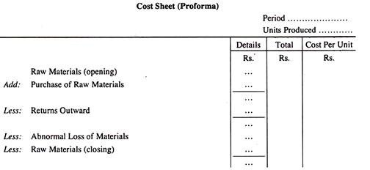
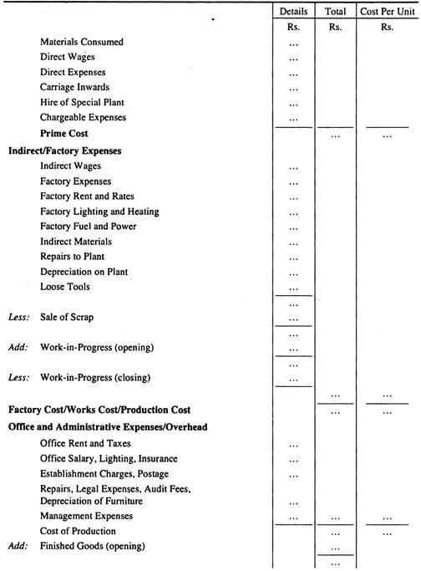
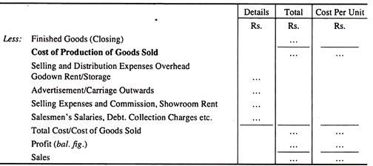

Objects of Cost Sheet

1. For determining the selling price
A cost sheet helps in determination of selling price of a product or of a service. Cost sheet ascertains cost at each stage of the product and also the total cost of the product, where a margin of profit is added and thus the selling price is ascertained.

2. Facilitating in managerial decision making
Preparation of cost sheet helps managers at various levels in their decision-making process such as-1. To produce or buy a component, 2. What price of goods to quote in the tender, 3.Whether to retain or replace an existing machine, 4. How to reduce costs and maximize profit. 5. Iidentify and make decisions whether they need to continue with the product or not.

3. Preparation of budgets
Organizations can prepare a budget with the help of a cost sheet. We can prepare the budget by using the current or previous year’s data.Based on our existing cost sheet, we can make estimates of our cost for the next financial year. It helps to prepare and make the necessary arrangement of funds for costs of the next financial year

Elements of Cost
Prime Cost: It comprises of direct material, direct wages, and direct expenses. Alternatively, the Prime cost is the cost of material consumed, productive wages, and direct expenses.
Factory Cost: Factory cost or works cost or manufacturing cost or production cost includes in addition to the prime cost the cost in indirect material, indirect labor, and indirect expenses. It also includes amount or units of WIP or incomplete units at the end of the period.
Cost of Production: When Office and administration cost at the end of the period are added to the Factory cost, we arrive at the cost of production or cost of goods sold. Here, we make an adjustment for opening and Closing finished goods.
Total Cost: Total cost or alternatively cost of sales is the cost of production plus selling and distribution overheads.

Proforma of A Cost Sheet
 | PARTICULARS | AMOUNT | AMOUNT
 |  |  | TOTAL
 | DIRECT MATERIAL-PURCHASED
ADD | OP STOCK OF RAW MATERIAL
LESS | CL STOCK OF RAW MATERIAL
 | MATERIAL CONSUMED
ADD | DIRECT WAGES
ADD | DIRECT EXPENSES
 | PRIME COST
ADD | WORKS OR FACTORY OVERHEADS
 | Factory Overheads
ADD | OP STOCK OF WIP
LESS | CL STOCK OF WIP
 | WORK COST
ADD | ADMINISTRATION OR OFFICE OVERHEADS
 | COST OF PRODUCTION
ADD | SELLING AND DISTRIBUTION OVERHEADS
ADD | OP STOCK OF FG
LESS | CL STOCK OF FG
 | COST OF SALES
ADD | PROFIT MARGIN
 | SELLING PRICE

Method of Preparation of Cost Sheet
Step I | Prime Cost = Direct Material Consumed + Direct Labour + Direct Expenses  Direct Material= Material Purchased + Opening stock of raw material-Closing stock of raw material.
Step II | Works Cost = Prime Cost + Factory Overheads (Indirect Material + Indirect Labour + Indirect Expenses)+opening Work in progress-Closing Work in progress
Step III | Cost of Production = Works Cost + Office and Administration overheads + Opening finished goods-Closing finished goods
Step IV | Total Cost = Cost of Production + Selling and Distribution Overheads
Profit | Sales – Total Cost

Solved Example for You
From the following information prepare a cost sheet.
Particulars | Amount
Direct material-purchased | 80000
Direct material -Opening stock | 20000
Direct material -Closing Stock | 25000
Productive wages | 22,000
Direct Expenses | 5,000
Consumable stores | 4000
Factory manager salary | 15000
Unproductive wages | 7000
Factory Overheads | 12,000
Work-in-progress:
Opening stock | 13,000
Closing stock | 7,000
Office and administration overheads | 28,000
Opening stock of finished goods | 5000
Closing stock of finished goods | 10000
Selling and distribution overheads | 33,000
Company desires a margin of 20% profit on the cost of sales
Ans.
COST SHEET FOR THE MONTH OF__________ FOR XYZ.
 | PARTICULARS | AMOUNT | AMOUNT
 |  |  | TOTAL
 | DIRECT MATERIAL-PURCHASED | 80,000.00
ADD | OP STOCK OF RAW MATERIAL | 20,000.00
LESS | CL STOCK OF RAW MATERIAL | 25,000.00 | –
 | MATERIAL CONSUMED | 75,000.00 | 75,000.00
ADD | DIRECT WAGES |  | 22,000.00
ADD | DIRECT EXPENSES |  | 5,000.00
 | PRIME COST |  | 102,000.00
ADD | WORKS OR FACTORY OVERHEADS
 | Consumable stores | 4,000.00
 | Factory manager salary | 15,000.00
 | Unproductive wages | 7,000.00
 | Factory Overheads | 12,000.00 | 38,000.00
 |  |  | 140,000.00
ADD | OP STOCK OF WIP | 13,000.00
LESS | CL STOCK OF WIP | 7,000.00 | 6,000.00
 | WORK COST |  | 146,000.00
ADD | ADMINISTRATION OR OFFICE OVERHEADS |  | 28,000.00
 | COST OF PRODUCTION |  | 174,000.00
ADD | SELLING AND DISTRIBUTION OVERHEADS | 33,000.00 | 33,000.00
 |  |  | 207,000.00
ADD | OP STOCK OF FG | 5,000.00
LESS | CL STOCK OF FG | 10,000.00 | –
 | COST OF SALES |  | 202,000.00
ADD | PROFIT MARGIN @ 20% ON COST OF SALES |  | 40,400.00
 | SELLING PRICE |  | 242,400.00

