B.COM: SEM--2
Subject: CMA – i
CHAPTER: NON INTEGRARED ACCOUNTING
TEACHER: DR R.DAS
LECTURE NO. 01

TOPIC: Non-Integrated Accounting System
In a non-integrated accounting system two different sets of accounting records are maintained for Financial Accounting and Cost Accounting purposes. This system is also called as ‘cost ledger accounting system’. The Cost Accounts are also maintained in double entry bookkeeping as in the case of Financial Accounts.
The non-integrated system of accounting is followed in the following situations when:
(a) Principal ledgers are to be maintained in Costing Department,
(b) Principal accounts are to be maintained, and
(c) Journal entries are to be passed in Cost Accounts.
The main object of Cost Accounting is to analyze costs by functions i.e., jobs, processes, services and specific overhead categories such as administration, selling or distribution. The special ledger accounts necessary for this purpose depend upon the extent to which analysis is to be made. The maintenance of Cost Accounts under non-integrated system show the importance of Cost Accounting in the concern.
When a separate set of Cost Accounts are maintained, it must be ensured that it is properly linked to the Financial Accounts so as to facilitate easy reconciliation.
It is the responsibility of Cost Accountant in maintenance of Cost Accounting records in non- integrated accounting system, and the Financial Accountant will maintain the Financial Account¬ing records. In Cost Accounts no personal accounts are kept but the transactions affecting the nominal accounts are recorded in both accounts.
Inter-Locking of Accounts:
CIMA defines Interlocking of Accounts “as a system in which the cost accounts are distinct from financial accounts, the two sets of accounts being kept continuously in agreement by the use of control accounts or made readily reconcilable by other means.”
This system of accounting necessitates the maintenance of separate accounts under costing and finance functions and its periodical reconciliation. The Cost Accounts use the same basic data as the Financial Accounts, but frequently adopt different bases for matters such as depreciation and stock valuation.
Where separate Cost Accounting and Financial Accounting systems are operated, a Cost Ledger Control Account has to be maintained as a link between two sets of accounts. At the end of each accounting period, it is necessary to reconcile the Cost and Financial Accounts.
Principal Ledgers and Control Accounts:
The principal ledgers and control accounts maintained by Costing Department under non- integrated accounting system are explained below:
Principal Ledgers:
(1) Cost Ledger:
This ledger consists of all impersonal accounts and is made self-balancing by maintaining a control account for each of the other three ledgers explained below.
(2) Stores Ledger:
This ledger consists all stores accounts. Individual accounts are maintained for each item of store.
(3) Work-in-Progress Ledger:
In this ledger cost of materials, wages and overheads of each job undertaken is posted irrespective of job account maintained in this ledger.
(4) Finished Goods Ledger:
In this ledger accounts of completely finished products, jobs are contained. Individual accounts are maintained for each type of finished job, product etc.
Principal Control Account:
(1) General Ledger Adjustment (Control) A/c:
This account is essential to make the Cost Ledger ‘self-balancing’. All transactions of income and expenditure which originate in the Financial Accounts must be entered in the ledger for eventual transfer to Cost Accounts. The balance in this account will always be equal to the total of all the balances of the impersonal accounts.
(2) Stores Ledger Control A/c:
This account is debited with all purchases of materials for the stores and credited with all issues of materials.
(3) Work-in-Progress Ledger Control A/c:
It consists of all direct materials, direct wages, direct expenses, special purchases and expenses. Production overhead are debited to this account regarding total work-in-progress of different jobs at any time.
(4) Finished Goods Ledger Control A/c:
The total value of finished goods in stock is represented in this account. On sale of goods, the cost of such goods is credited to this account and debited to Cost of Sales Account.
Other important Control Accounts maintained in Cost Ledger are as follows:
(a) Wages Control A/c
(b) Production Overhead A/c
(c) Administration Overhead A/c
(d) Selling and Distribution Overhead A/c
(e) Cost of Sales A/c
(f) Costing Profit and Loss A/c
The small firms are exempted to maintain detailed cost records. Many organizations prefer to maintain only Financial Accounts and the cost information will be extracted from the Financial Accounts on ad hoc basis and the requirements of the situation.
The cost of maintaining two different sets of accounts will be higher and sometimes may lead to confusion. The cost ascertainment and analysis is crucial for managerial decision making at least cost.

Illustration:
The following balances are shown in the Cost Ledger of Vinak Ltd. As on 1st April. 2009:
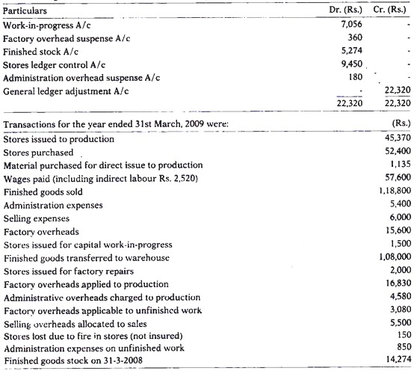
You are required to record the entries in the cost ledger for the year ended 31st March, 2009 and prepare a trial balance as on that date.

