CLASS NOTE
SEMESTER----2 (B.COM)
Subject: Marketing Management
TEACHER: DR B.CHANDRA
LECTURE NO. 03
Marketing Concepts
Marketing Concepts are;
1. Production Concept,
2. Product Concept,
3. Selling Concept,
4. Marketing Concept,
5. Societal Marketing Concept.
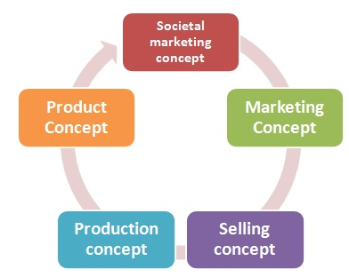

These concepts are described below;
1.Production Concept
The idea of production concept – “Consumers will favor products that are available and highly affordable”. This concept is one of the oldest Marketing management orientations that guide sellers.
Companies adopting this orientation run a major risk of focusing too narrowly on their own operations and losing sight of the real objective.
Most times; the production concept can lead to marketing myopia. Management focuses on improving production and distribution efficiency. Although; in some situations; the production concept is still a useful philosophy.
2. Product Concept
The product concept holds that the consumers will favor products that offer the most in quality, performance and innovative features.
Here; under this concept, Marketing strategies are focused on making continuous product improvements. Product quality and improvement are important parts of marketing strategies, sometimes the only part. Targeting only on the company’s products could also lead to marketing myopia. For example; Suppose a company makes the best quality Floppy disk. But a customer does really need a floppy disk?
She or he needs something that can be used to store the data. It can be achieved by a USB Flash drive, SD memory cards, portable hard disks, and etc.
So that the company should not look to make the best floppy disk. They should focus to meet the customer’s data storage needs.
3. Selling Concept
The selling concept holds the idea- “consumers will not buy enough of the firm’s products unless it undertakes a large-scale selling and promotion effort”.
Here the management focuses on creating sales transactions rather than on building long-term, profitable customer relationships.
In other words; The aim is to sell what the company makes rather than making what the market wants. Such an aggressive selling program carries very high risks.
In selling concept the marketer assumes that customers will be coaxed into buying the product will like it, if they don’t like it, they will possibly forget their disappointment and buy it again later. This is usually a very poor and costly assumption.
Typically the selling concept is practiced with unsought goods. Unsought goods are that buyers do not normally think of buying, such as insurance or blood donations.
These industries must be good at tracking down prospects and selling them on a product’s benefits.
4. Marketing Concept
The marketing concept holds- “achieving organizational goals depends on knowing the needs and wants of target markets and delivering the desired satisfactions better than competitors do”.
Here marketing management takes a “customer first” approach.
Under the marketing concept, customer focus and value are the routes to achieve sales and profits.
The marketing concept is a customer-centered “sense and responds” philosophy. The job is not to find the right customers for your product but to find the right products for your customers.

The marketing concept and the selling concepts are two extreme concepts and totally different from each other.

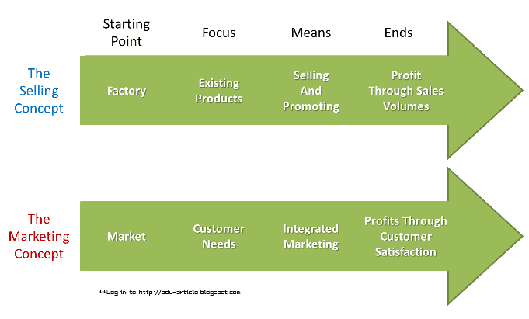
Difference between Selling Concept and Marketing Concept
- The selling concept focuses on the needs of the seller while the marketing concept focuses on the needs of the buyer
- The selling concept works to turn products into cash while the marketing concept works to satisfy the customers' needs through the product
- In the selling concept, competition is predominantly centered on sales while in the marketing concept the competition is centered on consumer satisfaction

5. Societal Marketing Concept
Societal marketing concept questions whether the pure marketing concept overlooks possible conflicts between consumer short-run wants and consumer long-run welfare.
The societal marketing concept holds “marketing strategy should deliver value to customers in a way that maintains or improves both the consumer’s and society’s well-being”.
It calls for sustainable marketing, socially and environmentally responsible marketing that meets the present needs of consumers and businesses while also preserving or enhancing the ability of future generations to meet their needs.
The Societal Marketing Concept puts Human welfare on top before profits and satisfying the wants.
The global warming panic button is pushed and a revelation is required in the way we use our resources. So companies are slowly either fully or partially trying to implement the societal marketing concept.
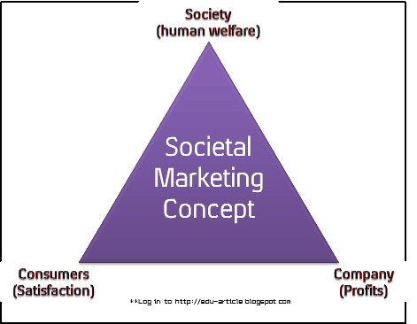

What Is More Important - Sales or Marketing and Why?
Marketing plays an important role in selling. It helps sales teams find and qualify leads and maintains contact with prospects throughout the sales cycle. Although sales and marketing reside in different departments in most organizations, integration between the two can help to improve overall performance in terms of revenue and profit.
Sales is important because it is the bottom line. Marketing is about getting a product known. At the end of the day, it's about the business bottom lines - and about getting results. You cannot sell a product without marketing. Marketing comes first. Advertising is about getting a product known. Marketing is about identifying a customer's need or want. If a customer doesn't need or want it, you can't sell it.
To prove this, let's say you are in the business of selling T-Shirts. You advertise all of the quality and custom graphics of this new T-shirt line that your trying to sell. You have two potential customers. Jack and Jill. Jack is a brick layer for a construction company. Jill is an college student.
There are two customers in front of you at the store and you really want to sell this these cool T-Shirts. Wouldn't you say that your probably going to spend more time explaining the quality and custom graphics of these T-Shirts to Jill. Your probably going to show her why she needs to wear these shirts, how this t-shirts is going to make her fashionable and feel great about her style. How this t-shirt is going to help her stay more update with the fashion trends, etc. etc.
Your marketing started when you were faced with two potential leads. You identified their occupation which allowed you the opportunity to convert the lead into a sale.
You can do all the advertising you want to both Jack and Jill. However, this is not enough to sell a product to a customer. You have to be able to convert the lead into a sale by identification which is a part of marketing. If you never explained to Jill how she needs this t-shirt in her life to make her more fashionable, you never would have sold it. If you take a little more time finding out about Jack, perhaps you can sell him too. Perhaps he has a t-shirt collection on the side.
Do a little more fact finding about Jack, the lead and see if there is a fit where your custom t-shirt would make it a must have for his collection. Then too, perhaps you can convert this lead into a second sale.
BOTTOM LINE
"You cannot sell a product or services without marketing. Marketing comes first."

