STUDY NOTE
UG : SEMESTER----2
Subject: Marketing Management
TEACHER: DR. P. K. SEN
LECTURE NO. 02
UNIT –II TOPIC: PRODUCT

Characteristics of Product
1. It can be a single commodity or a service; a group of commodities or a group of services; a product service combination, or even a combination of several products and services.
2. Its meaning is determined by the needs and desires of the consumer. The purpose of a product is to satisfy some need of the consumers. The buyers purchase problem-solving and time for creativity when they purchase a computer system.
3. It may be durable such as those that are expected to deliver a stream of satisfaction over a period of time,
4. Products may be luxuries which might be needed as a symbol of prestige and status such as car, a well- furnished bungalow in a posh colony or necessities which are needed to keep the body and soul together, such as bread, milk, sugar, etc.
5. It may be an agricultural, mineral, forest or semi-manufactured or manufactured product.

Importance of Product
1. Central Point for All Marketing Activities:
Product is the foundation of all the marketing activities such as, selling, purchasing, advertisement, distribution, sale promotion, etc. It is the product which is the vehicle of profitability for the business.
2. Starting Point of Planning:
The starting point of any marketing programme is the product. Planning for all marketing activities such as distribution, price, sales promotion, advertising, etc. is made on the basis of the nature, quality and the demand for the product. Product policies decide all other policies.
3. Product is an End:
The main objective of all marketing activities is to satisfy the customers. Various policies and techniques are formulated to provide the customers benefits, utilities and satisfactions through the product. Thus, product is the means for satisfaction of customers. The producer must insist on the quality and functionality of the product so that it may satisfy the customer’s needs.
4. Product is Indispensable:
Product is a must for marketing activities. All marketing activities are done for the satisfaction of customer. The producers must know their customers and their needs. They should also know their product and its qualities.
The product must contain the qualities which can satisfy the customers, should make continuous and sincere efforts to know their product through marketing research and planning and to improve it wherever it is lacking.

The Product Mix
The product mix is a combination of products manufactured or sold by the same organization. Generally companies offer an assortment of related or unrelated products to the markets instead of focusing on a single product to strengthen their presence in the market and increase profitability.
Smaller or medium firms usually offer products that are related to each other while bigger ones go for large scale diversification.
For example- Ayur Herbals, a comparatively smaller enterprise basically deals with cosmetics and beauty products while giants like Reliance group and Tata industries have their presence in varied fields like telecom, processed food, consumer goods, etc. Dealing with multiple products enables a firm to expand its customer base and spread risk among its various offerings. The product mix includes both product lines and product items.
(i) Product Line:
Product line is a group of products that are closely related either because they satisfy a class of need, or used together, are sold to the same customer group, are marketed through the same types of outlets, or fall within given price ranges or that are considered a unit because of marketing, technical, or end-use considerations. For example, The Sunsilk range of shampoos and conditioners constitute a product line.

(ii) Product Item:
It is a distinct unit within the product line that is separate from others on basis of colour, size, price or other attributes. For example, Sunsilk Thick and Long shampoo is a product unit distinguishable from other items in the product range.

Structure of Product Mix:
1. Width:
Width of the product mix means the number of different product lines found within the company. Thus, breadth is measured by the number of product lines carried. For example, Bajaj group has a number of subsidiaries under it producing bulbs, fluorescent lights, mixers and grinders, toasters, motorcycles, pressure cookers and a host of other products.

2. Length:
Length of the product mix refers to the total number of products in the mix. That is if a company has 5 product lines and 10 products each under those product lines, the length of the mix will be 50 [5 x 10].
3. Depth:
Depth of the product mix refers to the average number of items offered by the company within each product line. It is measured by assortment of sizes, colours, models, prices and quality offered within each product line. For instance, Hindustan Unilever offers a number of variants like Lux Fresh Splash, Strawberry and cream, Peach and cream, Sandal and cream, etc. within the product line Lux soaps.
4. Consistency:
The consistency of product mix points out how closely related the various product lines are in terms of consumer behaviour, production requirements, distribution channels or in some other way. For example, the products produced by the General Electric Company have an overall consistency in that most products involve electricity in one way or the other.
According to Kotler, all three dimensions of product mix have a market rationale. By increasing the width of the product mix the company hopes to capitalise on its good reputation and skills in present markets.
By increasing the depth of its product mix, the company hopes to entice the patronage of buyers of widely differing tastes and needs. By increasing the consistency of its product mix, the company hopes to acquire an unparalleled reputation in a particular area of endeavour.

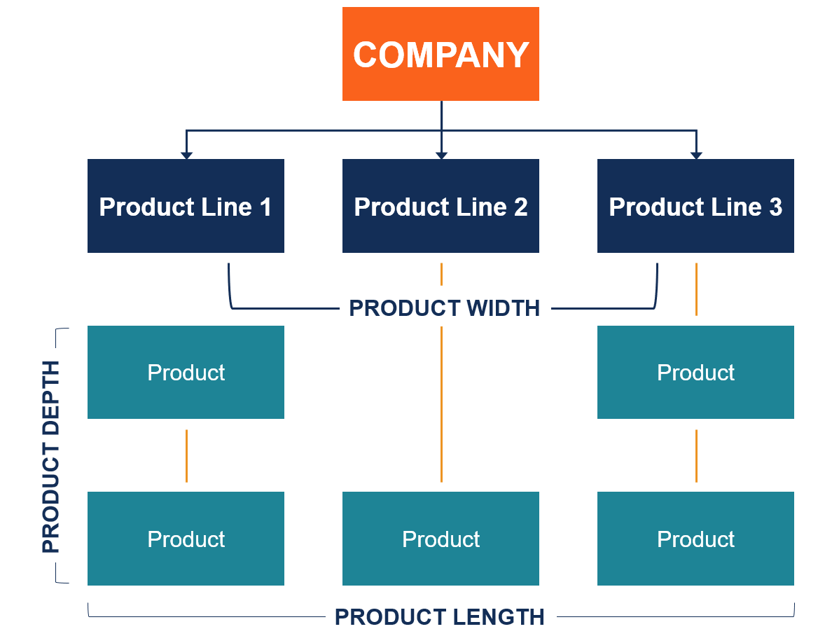

Determinants of the Product Mix
Conditions which appear to exert a major influence on the product- mix decision are:

1. Technology:
Comparatively little industrial research is basic in the sense that it is directed to the discovery of new principles or knowledge. By far the greatest industrial use of research and development is in the application of existing knowledge to the development of new products and processes or the improvement of existing ones.
The rate of technological change is accelerating, and technical research is unquestionably the most basic force affecting the product mix of the individual company.

2. Competition:
A second important determinant of a firm’s product mix is changes in competitors’ product offerings. Closely related is the introduction of competitive products by companies not now considered to be competitors.
This has happened increasingly in recent years, with the growing tendency of industrial firms to enlarge their product mixes to include product lines in fields and markets not previously served.
Changes in competitive products represent a direct challenge to a company, and if the change is a truly significant improvement, it may prove disastrous unless it can be matched or surpassed within a reasonable length of time.
This matter of the time element explains why firms seemingly in a solid product position spend large sums on research to discover new products that render their present ones obsolete. When asked why his firm was doing this, one chief executive replied, ‘If we don’t, someone else will.”
In addition to changes in their product designs, competitors may make changes in their overall product mix and put a rival at a competitive disadvantage. There are important forces favoring a product mix of considerable breadth. Broadening product lines may be a real advantage in distributor relations and in lowering selling costs.
The number of competitors may change. An increase in numbers is likely to result in keener competition and lowered profit margins. Significant increases in numbers of competitors are especially likely in industries where the capital investment necessary for entry is modest.
In such situations, a product that enjoys a rapid increase in sales is likely to attract many new entrants into the field, some of whom will not survive the period of consolidation, or “shakeout,” as it is sometimes called.
In industries that require large investment, increases in the number of competitors are less dramatic. When they occur, the new competitors tend to reach for volume by cutting price, which reduces both the dollar sales and the gross profit rate of the original innovator.
The result is that as soon as a firm introduces a new product on the market, it starts research to improve it and to find other new products to replace it when competition develops.

3. Operating Capacity:
Another important factor influencing a marketer’s product mix is underutilized capacity. Since production facilities are usually composed of complexes of interrelated machines, changes in production capacity can rarely be made in small increments.
When demand outruns existing facilities and a new equipment complex is brought on line, there may be a period in which it is not totally utilized in satisfying existing demand.
In such situations it is very common for management to be under pressure to find new products which the equipment can make. Similarly, when a marketing organization is established to serve a particular territory for a given product line, it often becomes apparent that salesmen could handle other lines as well, and pressure is generated to find other products they can sell profitably.
It is well known that many profitable firms do not pay out all their profits in dividends. Retained earnings become part of the firm’s capital structure and must be invested. New products are one of the investment opportunities into which underutilized funds are often channeled.
Many manufacturing processes involve by-products which must either be used internally, marketed, or disposed of as waste. Growing concern with industrial wastes may be expected to stimulate greater efforts than in the past to turn them into products which can either be used internally or marketed. The latter instance, of course, leads to an expansion of the product mix.

4. Market Factors:
Although declines in demand are disturbing to management and may result in an expansion of the product mix in an effort to replace lost business, upward changes are also of significance. Management’s responsibility is to capitalize as fully as possible on expanding product fields just as much as it is to meet the challenge of declining markets.

