SEMESTER – SEMESTER 4
SUBJECT – Strategic Management (Module 2)
NAME OF THE TEACHER – DEEPASHREE CHATTERJEE
LECTURE NO. – 1

STRATEGIC LEADERSHIP
The strategies that a company’s managers pursue have a major impact on the company’s performance relative to that of its competitors. A strategy is a set of related actions that managers take to increase their company’s performance. For most, if not all, companies, achieving superior performance relative to rivals is the ultimate challenge. If a company’s strategies result in superior performance, it is said to have a competitive advantage. Wal-Mart’s strategies produced superior performance from 2003 to 2012; as a result, Wal-Mart has enjoyed competitive advantage over its rivals.
Strategic leadership is about how to most effectively manage a company’s strategy-making process to create competitive advantage. The strategy-making process is the process by which managers select and then implement a set of strategies that aim to achieve a competitive advantage. Strategy formulation is the task of selecting strategies, whereas strategy implementation is the task of putting strategies into action, which includes designing, delivering, and supporting products; improving the efficiency and effectiveness of operations; and designing a company’s organizational structure, control systems, and culture.
We have already learnt in earlier lessons that bringing a change in strategy as and when required is an integral part of business organization. Central to strategic change is ensuring that people make a strategy happen. This chapter is about how managers can lead people to effect strategic change. This leadership role is most often associated with chief executives, but, in fact, it may occur at different levels in organisations: other senior managers and middle managers too may take leadership roles in change. Thus management of changes builds on four key premises:
- Strategy matters. We have understood in earlier lessons the importance of identifying the need for and direction of strategic change.
- Context matters. The approach taken to managing strategic change needs to be context dependent. There is, therefore, no ‘one right way’ of managing strategic change. Managers need to consider how to balance different approaches according to the circumstances they face.
- Inertia and resistance to change are likely. Managers report that the major problem in managing change is the tendency of people to hold on to existing ways of doing things.
- Leadership matters. This does not mean that leadership of change is always and exclusively from the top of an organisation – though such leadership does matter. Leadership of change needs to happen at different levels in an organisation.
Key elements in managing strategic change
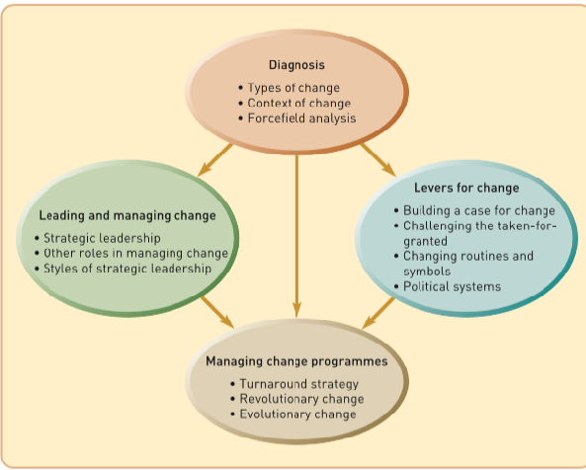

STRATEGIC LEADERSHIP, COMPETITIVE ADVANTAGE, AND SUPERIOR PERFORMANCE
Strategic leadership is concerned with managing the strategy-making process to increase the performance of a company, thereby increasing the value of the enterprise to its owners, its shareholders. As shown in Figure 1.2, to increase shareholder value, managers must pursue strategies that increase the profitability of the company and ensure that profits grow. To do this, a company must be able to outperform its rivals; it must have a competitive advantage.

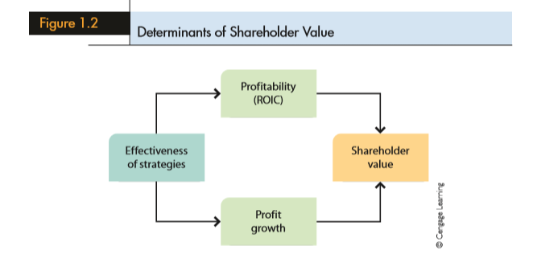

STRATEGIC LEADERSHIP
One of the key strategic roles of both general and functional managers is to use all their knowledge, energy, and enthusiasm to provide strategic leadership for their subordinates and develop a high-performing organization. Several authors have identified a few key characteristics of good strategic leaders that do lead to high performance: (1) vision, eloquence, and consistency; (2) articulation of a business model; (3) commitment; (4) being well informed; (5) willingness to delegate and empower; (6) astute use of power; and (7) emotional intelligence.
- Vision, Eloquence, and Consistency
One of the key tasks of leadership is to give an organization a sense of direction. Strong leaders seem to have a clear and compelling vision of where the organization should go, are eloquent enough to communicate this vision to others within the organization in terms that energize people, and consistently articulate their vision until it becomes part of the organization’s culture. In the political arena, John F. Kennedy, Winston Churchill, Martin Luther King, Jr and Margaret Thatcher have all been regarded as examples of visionary leaders. Think of the impact of Kennedy’s sentence, “Ask not what your country can do for you, ask what you can do for your country.
Examples of strong business leaders include Microsoft’s Bill Gates; Jack Welch, the former CEO of General Electric; and Sam Walton, Wal-Mart’s founder. For years, Bill Gates’s vision of a world in which there would be a Windows-based personal computer on every desk was a driving force at Microsoft.
- Articulation of the Business Model

Another key characteristic of good strategic leaders is their ability to identify and articulate the business model the company will use to attain its vision. A business model is managers’ conception of how the various strategies that the company pursues fit together into a congruent whole. At Dell, for example, it was Michael Dell who identified and articulated the basic business model of the company: the direct sales business model. The various strategies that Dell has pursued over the years have refined this basic model, creating one that is very robust in terms of its efficiency and effectiveness. If strategic leaders lack a clear conception of the company’s business model (or what it should be), it is likely that the strategies the firm pursues will not fit together, and the result will be lack of focus and poor performance.

- Commitment

Strong leaders demonstrate their commitment to their visions and business models
by actions and words, and they often lead by example. Nucor is a very efficient steelmaker with perhaps the lowest cost structure in the steel industry. It has achieved 30 years of profitable performance in an industry where most other companies have lost money due to a relentless focus on cost minimization. In his tenure as CEO, Iverson set the example: he answered his own phone, employed only one secretary, drove an old car, flew coach class, and was proud of the fact that his base salary was the lowest of the Fortune 500 CEOs (Iverson made most of his money from performance-based pay bonuses). This commitment was a powerful signal to employees that Iverson was serious about doing everything possible to minimize costs. It earned him the respect of Nucor employees and made them more willing to work hard.

- Being Well Informed

Effective strategic leaders develop a network of formal and informal sources who keep them well informed about what is going on within the company. Using informal and unconventional ways to gather information is wise because formal channels can be captured by special interests within the organization or by gatekeepers— managers who may misrepresent the true state of affairs to the leader. At Starbucks, for example, the first thing that former CEO Jim Donald did every morning was call 5 to 10 stores, talk to the managers and other employees there, and get a sense for how their stores were performing. Donald also stopped at a local Starbucks every morning on the way to work to buy his morning coffee. This allowed him to get to know individual employees there very well. Donald found these informal contacts to be a very useful source of information about how the company was performing.

- Willingness to Delegate and Empower

High-performance leaders are skilled at delegation. They recognize that unless they learn how to delegate effectively, they can quickly become overloaded with responsibilities. They also recognize that empowering subordinates to make decisions is a good motivational tool and often results in decisions being made by those who must implement them. At the same time, astute leaders recognize that they need to maintain control over certain key decisions. Thus, although they will delegate many important decisions to lower-level employees, they will not delegate those that they judge to be of critical importance to the future success of the organization, such as articulating the company’s vision and business model.

- The Astute Use of Power

Strategic leaders must often play the power game with skill and attempt to build consensus for their ideas rather than use their authority to force ideas through; they must act as members of a coalition or its democratic leaders rather than as dictators. power comes from control over resources that are important to the organization: budgets, capital, positions, information, and knowledge. Politically astute managers use these resources to acquire another critical resource: critically placed allies who can help them attain their strategic objectives.

- Emotional Intelligence

Emotional intelligence is a term that Daniel Goleman coined to describe a bundle of
psychological attributes that many strong and effective leaders exhibit
: • Self-awareness—the ability to understand one’s own moods, emotions, and drives, as well as their effect on others.
• Self-regulation—the ability to control or redirect disruptive impulses or moods, that is, to think before acting.
• Motivation—a passion for work that goes beyond money or status and a propensity to pursue goals with energy and persistence.
• Empathy—the ability to understand the feelings and viewpoints of subordinates and to take those into account when making decisions.
• Social skills—friendliness with a purpose.

According to Goleman, leaders who possess these attributes—who exhibit a high degree of emotional intelligence—tend to be more effective than those who lack these attributes. Their self-awareness and self-regulation help to elicit the trust and confidence of subordinates.
Empathetic and socially adept individuals tend to be skilled at remedying disputes between managers, better able to find common ground and purpose among diverse constituencies, and better able to move people in a desired direction compared to leaders who lack these skills. In short, Goleman argues that the psychological makeup of a leader matters

