UNIT 5: PROMOTION AND RECENT DEVELOPMENTS IN MARKETING
Semester- II (UG)
Subject- Marketing Management
Topic-Personal Selling, Public Relations and Sales promotion
By- Dr. Sushita Chakraborty
Lecture no-2
Personal Selling:
As per Philip Kotler, “Personal selling is a type of personal or local presentation by the firm’s sales force for the motive of making sales and building customer relationship.”
A famous writer W.J. Stanton says, “Personal selling involves individual personal communication in contrast to mass relatively impersonal communication of sales promotion, advertising, and other promotional tools.”
Cundiff and Still, “Personal selling is kind as a method of communication. It includes not only individual but social behaviour each of the individual in face contrast salesperson a prospect influence the others.”
Personal Selling:
Most effective tool at the later stages of the buying process, particularly in building up buyer preferences, conviction, and action. Three distinctive qualities are:

- Personal confrontation: immediate interactive relationship between two parties and ability to observe the other’s reaction at close hand.
- Cultivation: permits all kind of relationship to build up, ranging from a matter off act selling relationship to a deep personal friendship.
- Response: makes the buyer feel under some obligation for having to listened to the sales talk

Characteristics of personal selling:
- Personal Form of face to face interaction
- Development of Relationship by winning the confidence, trust of customer
- Oral Conversation with twoway communication
- Quick Solution of Queries i.e. immediate feedback
- It persuades the customers instead of pressurizing them.
- It develops a deep personal relationship apart from the selling relationship with the buyers and customers.
- It has been observed that twenty percent of the sales are affected through personal selling.
- By personal selling the salesman reaches the prospective buyers whom other promotional measures cannot reach.
- Personal selling is flexible, as it can adjust to the immediate reactions of the potential buyers.
- Feedback of sales efforts is possible in personal selling.
- Personal selling is the easy way to find the target consumer

The Personal Selling Process:
The selling process are the steps that salespeople follow when selling, which include prospecting and qualifying, pre-approach, approach, presentation an demonstration, handling objections, closing and following up.
- Prospecting and Qualifying:
The step in the selling process in which a salesperson or company identifies qualified potential customers. So, the first step in selling is to identify and qualify prospects.
- Pre-approach:
The step in the selling process in which a salesperson learns as much as possible about the prospect company (what it needs, who is involved in the purchase decision) and its buyers ( their personal characteristics and buying styles)
- Approach:
The step in the selling process in which a salesperson should know how to greet the buyer to get the relationship off to a good start.
- Presentation and Demonstration:
The step in the selling process in which a salesperson tells the product “ story” to the buyer, following the AIDA formula of gaining attention, holding interest, arousing desire, and obtaining action. The salesperson uses a features, advantages ,benefits and value approach (FABV).Companies have developed three different styles of sales presentation, the Canned approach, Formulated approach and Need- satisfaction approach.
- Handling objections:
The step in the selling process in which a salesperson seeks out, clarifies and overcomes any customer objections to buying.
- Closing:
A salesperson asks the customer for an order.
- Following up:
The last step in the selling process in which a salesperson follows up after the sale to ensure customer satisfaction and repeat business. The steps in the selling process can be described as transaction oriented. But in most cases, the long-term goals are to develop a profitable relationship.
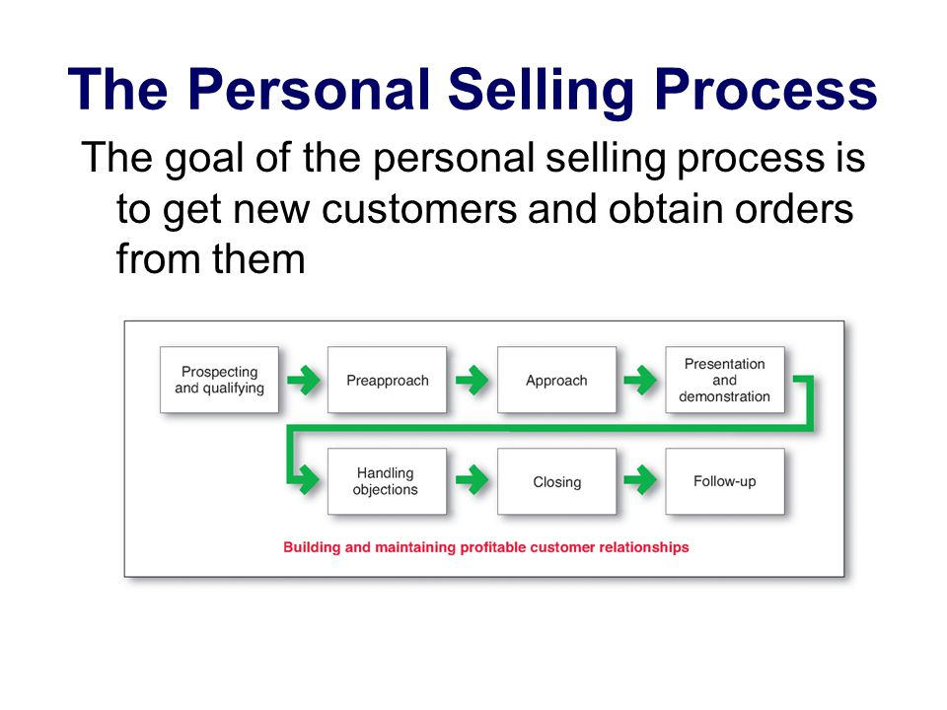
PUBLIC RELATIONS (PR):
Public Relations consists of variety of programmes designed and conducted by a company to build and protect good corporate image about the company or its individual product. So, the whole process of forming a bright image of a business among the public, is called the PR.

Various Definitions of Public Relations:
“A strategic management function that adds value to an organisation by helping it to manage its reputation.” -The Chartered Institute of Public Relations.
“The art and social science of analysing trends, predicting their consequences, counselling organisational leaders and implementing planned programme of action which will serve both the organisation and the public interest.” -Public Association Relations
According to Edward Barney, “Public relations are the attempt by information, persuasion, adjustment, to engineer public support for an activity, a cause, movement or an institution.”
Different aspects of public relations:
- To be ensured about public opinion and its analysis and evaluation;
- To advise about the desirable behaviour on the part of top level officers of the concern on the basis of public opinion;
- To use the model of communication in such a way that the public opinion can be influenced towards its objectives.
Public relations and publicity: The three distinctive qualities are:
- High credibility
- Ability to catch the buyers off the guard
- Dramatization

Functions of PR:
- Analyse the future trend and anticipate the probable result by presenting positive information about the company
- Formation of sense of responsibility of the company by influence the influential’ s.
- Build a core consumer base by improving in the quality of goods and services
- Harmonization of public interest with private interest
- Improvement of the industrial relations, attract the skilled workers towards the organisation and reduce the reduce the labour turnover
- Determination of the means of creation of good relation among the different interested groups of the concern.

FEATURES OF PUBLIC RELATIONS:
- Key managerial function
- Extension of Publicity
- Involves wide range of activities
- Reflects the philosophy of management
- Concerned with all level routine activity
- Ongoing flexible process
- Communication with various group of public
- PR promotes the entire Organisation.

Marston’s four- step “RACE” Model describes the PR Process where,
R=RESEARCH
A=ACTION
C=COMMUNICATION
E=EVALUATION
Sales Promotion:
According to Philip Kotler – “Sales promotion consists of a diverse collection of incentive tools, mostly short-term, designed to stimulate quicker and/or greater purchase of particular product/services by consumers or the trade.”
According to Philip Kotler, sales promotional tools have three distinctive characteristics:
- Communication
- Incentives
- Invitation
Sales promotion: The distinctive benefits are

- Communication: They gain attention and usually provide information that may lead to the consumer to the product.
- Incentive: They incorporate some concession, inducement, or contribution that gives value to the consumer.
- Invitation: They include a distinct invitation to engage in the transaction now. The company uses sales promotion tools to draw a stranger and quicker buyer response. Sales promotion can be used for short run effects such as to dramatize the product offers and boost sagging sales.
Managing the Sales Force:

Sales force management means analysing, planning, implementing and controlling sales force activities. There are six major steps in the sales force management process:
- Designing the sales force strategy and structure:
The sales force structure can have different shapes. A territorial sales force structure is a sales force organisation that assigns each salesperson to an exclusive geographic territory in which that salesperson sells the company’s full line. Territory sales representatives report to territory managers, who are under the supervision of regional managers, who in turn report to a director of sales.
A product sales force structure is a sales force organisation in which salespersons specialise in selling only a portion of the company’s products or lines. This might lead to trouble when customers buy multiple products of the same company and could lead to double work.
A customer or market sales force structure is a sales force organisation in which salespeople specialise in selling only to certain customers or industries. This can help a company build closer relationships with meaningful customers.
Finally combinations of sales force structures are possible, leading to complex structures. Once the structure is set, the sales force size must be determined. This can be done by the workload approach, where the number or salespersons are based on the amount of effort desired for different classes of work. Sales management must also determine who will be involved in the sales force. Outside sales force (field sales force) are salespeople who travel to call on customers in the field. Inside sales force are salespeople who conduct business from their offices via telephone, the Internet or visits from prospective buyers. Team selling means using a team of people from sales, marketing, engineering, finance, technical support an even upper management to service large, complex, accounts.
- Recruiting and Selecting salespeople.
The success of a sales force operations depends on the skills of salespeople. Good sales people are motivated, disciplined, have skills and knowledge and a great understanding of customer needs. Careful salesperson selection can greatly increase overall sales force performance. When recruiting, a company should analyze the sales job itself and the characteristics of its most successful salesperson to identify the traits needed by a successful salesperson in their industry. Then, it must recruit the right salespeople.

- Training salespeople
Most companies provide continuous sales training. Training programmes teach salespeople what they need to know about their customers and give them the necessary skills. So an effective training program teaches them about the company’s objectives, organization, and chief products and markets, and about the strategies of major competitors.
- Compensating salespeople
To attract good salespeople, they need to be compensated i.e. a company must have an appealing compensation plan. Compensation is made up of several elements: a fixed amount, a variable amount, expenses and fringe benefits. The fixed amount, usually a salary, gives the salesperson some stable income. The variable amount, which might be commissions or bonuses based on sales performance, rewards the salesperson for greater effort and success. Management must decide what mix of these compensation elements makes the most sense for each sales job.

- Supervising and Motivating salespeople
The goal of supervision is to help salespeople work smart, by doing the right things the in the right way. Motivation helps salespeople to work hard to reach the sales force goals. Supervising salespeople can be done by period call plans and time-and-duty analysis. Sales 2.0 is the merging of innovative sales practices within Web 2.0 technologies to improve sales force effectiveness and efficiency. Beyond directing, sales managers must also motivate salespeople. Sales quota are standards that state the amount a salesperson should sell and how sales should be divided among the company’s products. Organisational climate describes the feeling salespeople have about their opportunities, value and rewards for a good performance. Sales meetings provide social occasions, breaks from routine, chances to meet and talk with “company brass” and opportunities to air feelings and to identify with a larger group. Companies also sponsor sales contests to spur the sales force to make a selling effort above what would normally be expected. Other incentives include honors, merchandise and cash awards, trips, and profit sharing plans.
- Evaluating salespeople
The last step in the process is evaluating the salespeople. Information can be gathered by the management in different ways: via sales reports call reports and expense reports. Using various sales force reports and other information, sales management evaluates members of the sales force. It evaluates salespeople on their ability to “ plan their work and work their plan.”Formal evaluation forces management to develop and communicate clear standards for judging performance. It also provides salespeople with constructive feedback and motivates them to perform well.
- Purpose of Sales promotion: Sellers use incentive-type promotions to attract new triers, to reward loyal customers, & to increase the repurchase rates of occasional users. Price promotions usually build short-term volume that is not maintained, but it enables manufacturers to adjust to short-term variations in supply & demand.
- Sales promotion objectives: Encouraging purchase, building trial for nonusers, attracting switchers from competitors, increase inventory in retailers, encourage off-season buying, support of a new product, etc.
- Sales promotion tools: Distinguished between manufacturer promotions & retailer promotions to consumers. Sales prom seems most effective when used together with advertising, & even more with point-of-purchase display.
- Trade-promotion tools: A higher proportion pie is devoted to trade-promotion tools than to consumer promotion, with media advertising capturing the rest. This is because trade promotion can persuade the retailer or wholesaler to carry the brand (shelf space), can persuade the retailer or wholesaler to carry more units, can induce the retailers to promote the brand by featuring, display, & price reductions, also can stimulate retailers & their sales clerks to push the product.

References:
- Gaurav Akrani- “Purpose, Features, Advantages, Role and 5M’s of advertising”(2010)
- Philip Kotler-“ Marketing Management”(2003, eleventh edition)
- Rajan Saxena-“Marketing Management”( 2009, Fourth edition)
- V S Ramaswamy and S Namakumari-“ Marketing Management -Planning, Implementation and Control”. ( 2009, Fourth edition).
- Philip Kotler, Gary Armstrong ,Prafulla Y. Agnihotri, Ehsan ul Haque, Kevin Lane Keller, Abraham Koshy, Mithileshwar Jha, “Marketing Management – for IMT, Ghaziabad”

