CLASS NOTE
B.COM: SEM--6
Subject: FINANCIAL MANAGEMENT
CHAPTER: WORKING CAPITAL - II
TEACHER: DR B.CHANDRA
LECTURE NO. 01

SUB: FINANCIAL MANAGEMENT
CHAPTER: WORKING CAPITAL - II
TOPIC; Policies relating Current Assets – Conservative, Aggressive and Balanced ; Various sources of finance to meet working capital requirements; Financing current assets: Strategies of financing (Matching, Conservative, and Aggressive policies) ; Management of components of working capital (debtors management only–credit period -simple type)
Sub Topic – 1: Policies relating Current Assets – Conservative, Aggressive and Balanced
ANSWER
Working capital financing policy basically deals with the sources and the amount of working capital that a company should maintain. A firm is not only concerned about the amount of current assets but also about the proportions of short-term and long-term sources for financing the current assets. There are several working capital investment policies a firm may adopt after taking into account the variability of its cash inflows and outflows and the level of risk.
1. Hedging Policy:
One of the policies by which a firm finances its working capital needs is the hedging policy, also known as matching policy. This policy works in an arrangement where the current assets of the business are used perfectly to match the current liabilities. As per this approach, fixed and permanent current assets are financed through long-term sources and fluctuating current assets are financed through short-term sources. This policy is a medium risk proposition and requires a good amount of attention. For example, if a bank loan is due to be paid after six months, the company will ensure that sufficient amount of cash will be available to repay the loan on the date of maturity even though it may or may not currently have sufficient cash. In case of a growth firm, the amount of fixed assets and permanent current asset go on increasing with the passage of time but the volume of fluctuating current assets change with the change in production level. In Figure 8.1, Line A and Line B is upward slopped indicating that they go on increasing with the passage of time and as per hedging principle they are financed through long-term sources like equity and long-term debt. Fluctuating current assets, which are shown by the curved Line C, should be financed through short term sources.

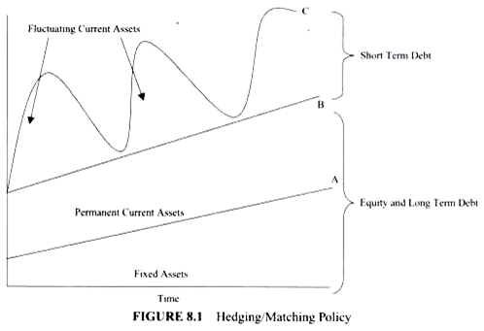
2. Conservative Policy:
As the name suggests, this policy tries to avoid the risk involved in financing of current assets. Here, relatively high proportions of long-term sources are to be used for financing current assets. The firm not only matches the current assets with current liabilities but also keeps some excess amount to meet any uncertainty. This is the lowest risk working capital policy and fails to ensure optimum utilization of funds. Hence it cuts down the expected returns of the shareholders. This policy is illustrated in Figure 8.2. Line A denotes the fixed assets and Line B denotes the permanent working capital, which is financed through long-term sources. Certain portion of fluctuating current assets, which is shown by dashed Line C, is also financed by long-term sources. Under this policy some part of fluctuating current assets is financed through short-term sources.
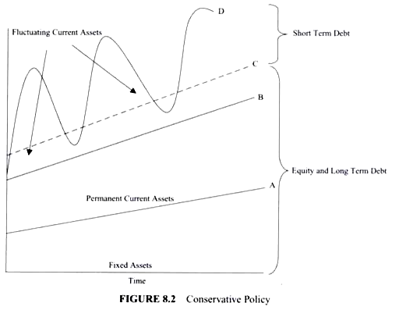

3. Aggressive Policy:
Aggressive working capital financing policy is a risky policy that requires maximum amount of investment in current assets. Fluctuating as well as permanent current assets under this policy will be financed through short-term debt. In this policy debt is collected on time and payments to the creditors are made as late as possible. This policy has been illustrated in Figure 8.3. According to this approach long-term sources are used to finance the fixed assets, which are shown by Line A; but a portion of permanent current assets, shown by the dotted Line B, is also financed through long-term sources. The remaining part of permanent current assets, depicted by Line C, and the entire amount of fluctuating current assets, shown by the curved Line D, are financed by short-term debt.
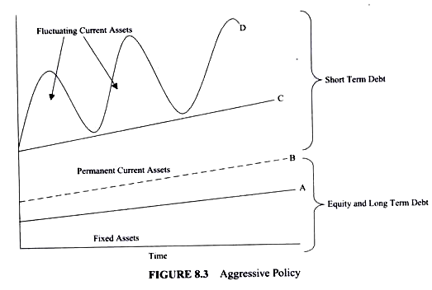
4. Highly Aggressive Policy:
This is a highly risky policy for financing the working capital. As per this policy, even some part of fixed assets is financed through short-term sources. Excessive reliance on short-term sources makes this policy highly risky. This policy has been illustrated in Figure 8.4. A major proportion of fixed assets as shown by dotted Line A are financed through long-term sources and the remaining part of the fixed assets are financed by short-term sources—shown by Line B. Short-term sources are also used for financing permanent current assets—Line C; as well as fluctuating current assets as shown by the curved Line D.
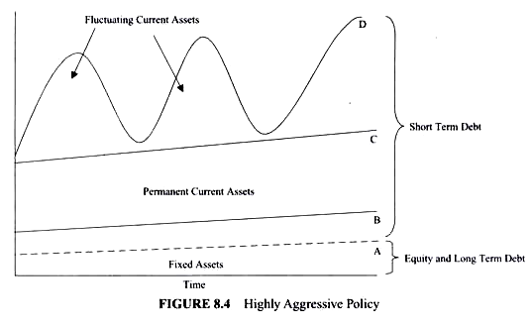

Working Capital Management Strategies
The following points highlight the top approaches of working capital management strategies. They are:- 1. Conservative Approach 2. Aggressive Approach 3. Matching Approach
1. Conservative Approach:
A conservative strategy suggests not to take any risk in working capital management and to carry high levels of current assets in relation to sales. Surplus current assets enable the firm to absorb sudden variations in sales, production plans, and procurement time without disrupting production plans. It requires to maintain a high level of working capital and it should be financed by long-term funds like share capital or long-term debt. Availability of sufficient working capital will enable the smooth operational activities of the firm and there would be no stoppages of production for want of raw materials, consumables. Sufficient stocks of finished goods are maintained to meet the market fluctuations. The higher liquidity levels reduce the risk of insolvency. But lower risk translates into lower return. Large investments in current assets lead to higher interest and carrying costs and encouragement for inefficiency. But conservative policy will enable the firm to absorb day to day business risks and assures continuous flow of operations. Under this strategy, long-term financing covers more than the total requirement for working capital. The excess cash is invested in short-term marketable securities and in need, these securities are sold-off in the market to meet the urgent requirements of working capital.
Financing Strategy
Long-term funds = Fixed assets + Total permanent current assets + Part of temporary current assets
Short-term funds = Part of temporary current assets
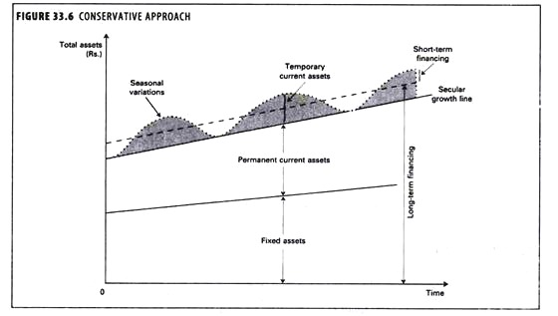
2. Aggressive Approach:
Under this approach current assets are maintained just to meet the current liabilities without keeping any cushion for the variations in working capital needs. The core working capital is financed by long-term sources of capital, and seasonal variations are met through short-term borrowings. Adoption of this strategy will minimize the investment in net working capital and ultimately it lowers the cost of financing working capital. The main drawbacks of this strategy are that it necessitates frequent financing and also increases risk as the firm is vulnerable to sudden shocks. A conservative current asset financing strategy would go for more long-term finance which reduces the risk of uncertainty associated with frequent refinancing. The price of this strategy is higher financing costs since long-term rates will normally exceed short term rates. But when aggressive strategy is adopted, sometimes the firm runs into mismatches and defaults. It is the cardinal principle of corporate finance that long-term assets should be financed by long-term sources and short-term assets by a mix of long and short-term sources.
Financing Strategy
Long-term funds = Fixed assets + Part of permanent current assets
Short-term funds = Part of permanent current assets + Total temporary current assets

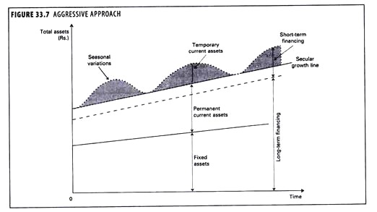
3. Matching Approach:
Under matching approach to financing working capital requirements of a firm, each asset in the balance sheet assets side would be offset with a financing instrument of the same approximate maturity. The basic objective of this method of financing is that the permanent component of current assets, and fixed assets would be met with long-term funds and the short-term or seasonal variations in current assets would be financed with short-term debt. If the long-term funds are used for short-term needs of the firm, it can identify and take steps to correct the mismatch in financing. Efficient working capital management techniques are those that compress the operating cycle. The length of the operating cycle is equal to the sum of the lengths of the inventory period and the receivables period. Just-in-time inventory management technique reduces carrying costs by slashing the time that goods are parked as inventories. To shorten the receivables period without necessarily reducing the credit period, corporate can offer trade discounts for prompt payment. This strategy is also called as hedging approach.
Financing Strategy:
Long-term funds = Fixed assets + Total permanent current assets
Short-term funds = Total temporary current assets

IMPORTANT DECISIONS IN WORKING CAPITAL MANAGEMENT – LEVEL OF CURRENT ASSET AND THEIR MEANS OF FINANCING.
Working capital management has two main decisions at two consecutive stages. They are as follows:
1. The level of Current Assets – How much to invest in Current Assets to achieve the Targeted Revenue?
2. Means of Financing Current Assets – How should the above Current Asset Investment be financed i.e. the mix of long and short term finance?
DIFFERENCE BETWEEN WORKING CAPITAL POLICIES AND WORKING CAPITAL FINANCING STRATEGIES
Commonly, policies of working capital and strategies (approaches) of working capital financing are interchangeably used and which is not correct. There is a thin line of difference between the two. Working capital management policy deals with the first decision and working capital management strategies or approaches deal with the second decision. Working capital policies are restricted, relaxed and moderate whereas the working capital strategies are aggressive, conservative and hedging (Maturity Matching).
THREE TYPES OF WORKING CAPITAL POLICIES
Based on the attitude of the finance manager towards risk, profitability and liquidity, the working capital policies can be divided into following three types.
RESTRICTED POLICY
In restricted policy, the estimation of current assets for achieving targeted revenue is done very aggressively without considering for any contingencies and provisions for any unforeseen event. After deciding, these policies are forcefully implemented in the organization without tolerating any deviations. In the diagram, point R represents the restricted policy which attains the same level of revenues with lowest current assets. Adopting this policy would result in an advantage of the lower working capital requirement due to the lower level of current assets. This saves the interest cost to the company and which in turn produces higher profitability i.e. higher return on investment (ROI). On the other hand, there is the disadvantage in the form of high risk due to very aggressive policy. That is why; it is also called as aggressive working capital policy.
RELAXED POLICY
Relaxed policy is just the opposite of restricted policy. In this policy, the estimation of current assets for achieving the targeted revenue is prepared after careful consideration of uncertain events such as seasonal fluctuations, a sudden change in the level of activities or sales etc. After the reasonable estimates also, a cushion to avoid any unforeseen circumstances is left to avoid the maximum possible risk. In the diagram, it represents the point Rx which uses the highest level of current assets for achieving the same level of sales. The companies having relaxed working capital policies assume an advantage of almost no risk or low risk. This policy guarantees the entrepreneur of the smooth functioning of the operating cycle. We know that earnings are more important than higher earnings. On the other hand, there is a disadvantage of lower return on investment because higher investment in the current assets attracts higher interest cost which in turn reduces profitability. Because of its conservative nature, this policy is also called as conservative working capital policy.
MODERATE POLICY
Moderate policy is a balance between the two policies i.e. restricted and relaxed. It assumes characteristics of the both the policies. To strike a balance, moderate policy assumes risk which is lower than restricted and higher than conservative. In profitability front also, it lies between the two. The biggest benefit of this policy is that it has reasonable assurance of smooth operation of working operating capital cycle with moderate profitability. Working capital policies can be further framed for each component of net working capital i.e. cash, accounts receivable, inventory and accounts payable. Cash policies can be to maintain an appropriate level of cash. When the level is high, it should be invested in liquid investments for short term and vice versa. Accounts receivable policy may state about payment terms, credit period, credit limit, etc. Inventory policy may speak of minimizing the levels of inventory till the point it poses any risk to the satisfaction of customer demands. Accounts payable policies include policies of payment terms, quality terms, return policies, etc.

