SEMESTER – SEMESTER 2
SUBJECT – E-Commerce
NAME OF THE TEACHER – DEEPASHREE CHATTERJEE
LECTURE NO. - 1
Note: We understand that in this situation of lock down, you may not have access to library books. Hence, if anyone is interested to get a scanned copy of the chapters I am covering, please contact me in whatsapp at 9163019220 and I will send you the same.
Introduction
The integration of information and communications technology (ICT) in business has revolutionized relationships within organizations and those between and among organizations and individuals. Specifically, the use of ICT in business has enhanced productivity, encouraged greater customer participation, and enabled mass customization, besides reducing costs.
E-commerce in simple terms is buying and selling of goods around the web. However, it includes many other things like one business selling goods to other business, currency exchange involved in online business transacted between companies of different countries, gathering and analysis of data through web contact and social media, survey of prospective customers, engaging target audiences in pre-retailing, also known as pretailing activities, etc.
Is e-commerce the same as e-business?
While e-commerce and e-business are often being used interchangeably, they are distinct concepts. E-commerce is a major component of e-business
In e-commerce, information and communications technology (ICT) is commonly used in inter-business or inter-organizational transactions (transactions between and among firms/organizations) and in business-to-consumer transactions (transactions between firms/organizations and individuals). In e-business, on the other hand, information and communications technology (ICT) is used to enhance one’s business. It encompasses any process that a business organization (either a for-profit, governmental or non-profit entity) conducts over a computer-mediated network. It includes procurement, ordering and replenishment of stocks; processing of payments. Customer-focused process It includes promotional and marketing efforts, selling over the Internet, processing of customers’ purchase orders and payments, and customer support. Internal management process It includes employee services, training, internal information sharing, videoconferencing, and recruitment. Differences or relationship between e-commerce and e-business
• When electronic medium is used in commercial transaction (buying and selling of goods and services), then it is termed as e-commerce. When electronic medium is used in all the day-to-day activities, then it is termed as e-business.
• E-commerce includes transactions which are related to money, but e-business includes monetary as well as allied activities.
• E-commerce has an extroverted approach that includes customers, suppliers, distributors, etc. On the other hand, e-business has an ambivert approach that includes internal as well as external processes
• E-business and E-commerce both address the business processes, as well as a technology infrastructure of databases, application servers, security tools, system management and legacy systems.

Forms of E-Commerce
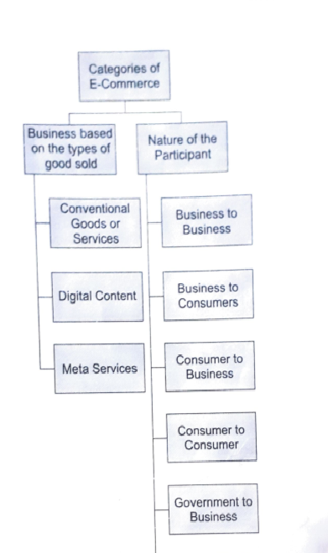
Based on the type of goods, it can be conventional goods like fashion wear, books, electrical appliances, etc., or digital contents like movies, songs serials, or meta services like GoDaddy which sets up website to facilitate e commerce activities of companies.
Categorization based on participants will be discussed in details in the following lectures.
Brief history
E-commerce, in its initial form of commercial transactions, emerged in the late 1970s. At this point, exchange of commercial documentation between businesses electronically was initiated. By 2000, businesses in America and Western Europe started to present the goods and services online. This is when traditional commerce emerged to e-commerce (online buying and selling) and e-business was born. Amazon and eBay were the first among e-businesses to allow electronic transactions.
IMPACT OF E-COMMERCE
- Market and retailers – Overall effect on market is positive. Price competition is healthy as correct product information is made available to customers, and customers can compare price easily on different websites. Geographical barriers have disappeared and new retailers have emerged as e-commerce requires less investment. However, some sectors like physical book stores or travel agents have been negatively impacted as people are now getting access to various online sites like yatra.com, goibibo, etc, from where they can make direct booking, after taking a note of customer’s feedback, etc.

- Impact on supply chain management – E-commerce helps improve the flow of goods and services and enables smooth processing of information with the help of various e-commerce software. Thus gaps in supply chain management are filled using electronic means and this enables efficient management of supply chain.

- Impact on employment – E-commerce has increased demand for various products, and increased demand should be compensated by increased supply, which would have a positive effect on employment. It has also led to an increased demand of tech –savvy people, delivery personnel, call centre employees for handling customer queries, etc. Some people working in bricks and mortar shops, however, might lose their jobs as more customers shift towards online purchasing.

- Socio Economic impact – Society has shifted more towards technology. Online advertising and marketing has gained popularity. Huge discounts offered to customers many a times make them buy products which are not necessary. Taking customer surveys and feedback have become a common trend.

Economically also, e-commerce have put a positive impact as the cost of running a e-commerce business is a lot lower. Rent need not be paid and website maintenance cost is low. Process for setting up and running the business is also simplified.

