B.COM: SEM--2
Subject: CMA I
TEACHER: DR D.BAIDYA
LECTURE NO. 02

Cost Accounting Problems With Solutions
Problem 1:
The accounts of Basudev Manufactures Ltd. for the year ended 31st December 1988 show the following:
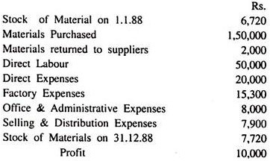
Find out:
- Material Consumed (b) Prime Cost (c) Works Cost (d) Cost of Production (e) Total Cost and (f) Sales.
Solution:
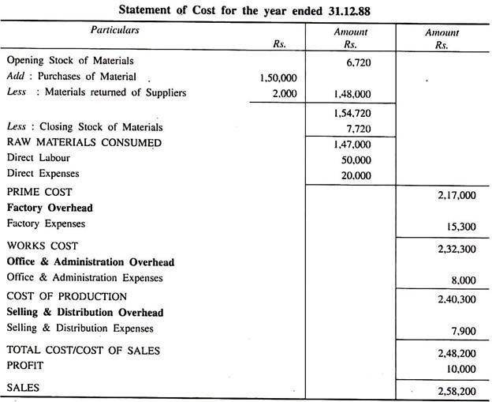
Problem 2:
Prepare a Cost Sheet for the year ended 31.3.86 from the following figures extracted from the books of Best Engineering Co.
Opening Stock:
(i) Raw Material 40,350,
(ii) Work-in-Progress 15,000 and
(iii) Finished Stock 35,590.
Cost incurred during the period:
Materials purchased 2,50,000, Wages paid 2,00,000, Carriage inward 2,000, Consumable Stores 10,000, Wages of Storekeeper 7,000, Depreciation of Plant & Machinery 10,000, Materials destroyed by Fire 5,000, Repairs & Renewals 5,010, Office Manager’s Salary 10,000, Salary to Office Staff 20,500, Printing & Stationary 10,000, Power 10,500, Lighting for Office Building 2,000, Carriage outward 3,000, Freight 5,000, Entertainment 2,500, Warehousing charges 1,500, Legal charges 2,000, Expenses for participating in Industrial exhibition-6,000.
Closing Stock:
(i) Raw material 35,000,
(ii) Work-in-Progress 14,500, and
(iii) Finished Stock 40,030. Profit 25% on cost.
Solution:
Best Engineering Co.
Cost Sheet:
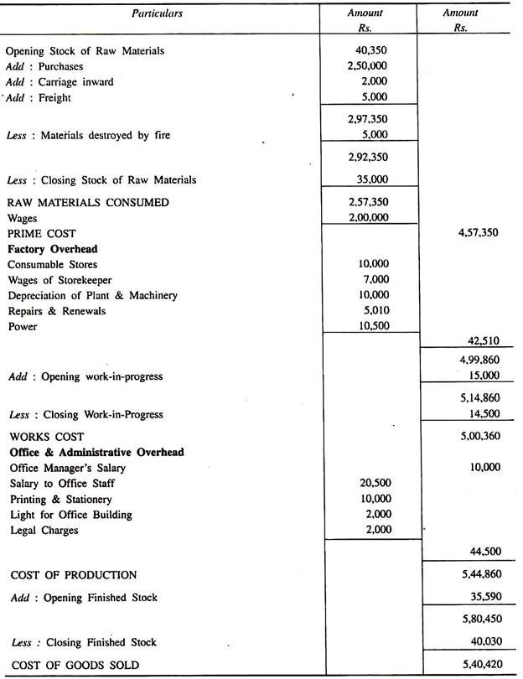
Problem 3:
From the following figures relating to the manufacture of a Electronic Product during the month of July 1990, prepare a statement showing Cost and Profit per unit:
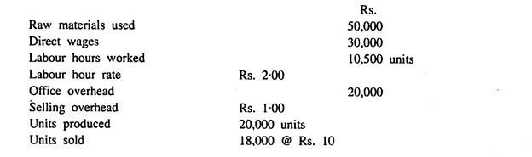
Solution:
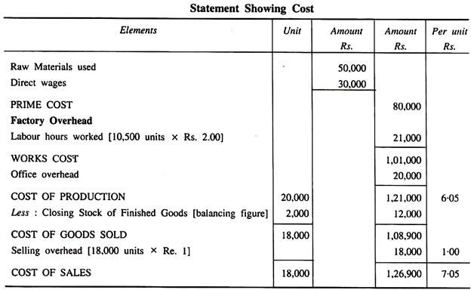
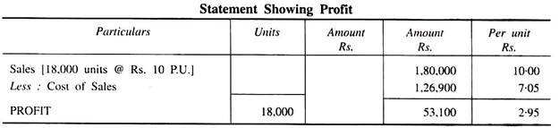
Working Notes:
Calculation of Closing Finished Stock:
Closing Finished Stock= Opening Finished Stock + Production – Sales
= Nil + 20,000 – 18,000 = 2,000.
Problem 4:
The following data are available for 2006:
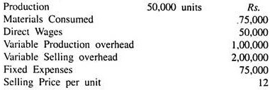
It is expected that in 2007:
(a) Production will be 1,00,000 units.
(b) Prices of materials will go up by 33⅓%.
(c) Variable selling overhead and fixed expenses will rise by 25% and Rs. 25,000, respectively. What would be the cost per unit and selling price in 2007, if it is desired to maintain the same rate of profit on sales as in 2006?
Solution:
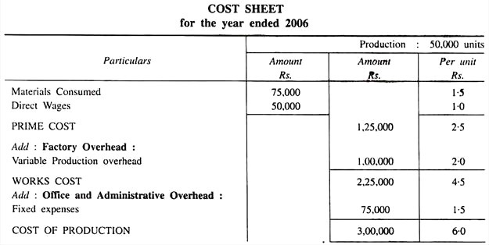
Working:
(i) Calculation for Material Cost per unit in 2007
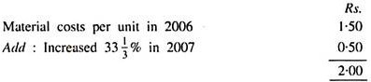
(ii) Calculation for cost per variable selling overhead in 2007
Selling overhead increased by 25% i.e. selling overhead per unit in 2007
= Rs. 4.00 + 25% of Rs. 4 = 4.00 + 1.00 = Rs. 5.00
(iii) Fixed expenses in 2007 = 75,000 + 25,000 = 1,00,000
(iv) Rate of profit on sales = 2/12 × 100 = 16⅔%
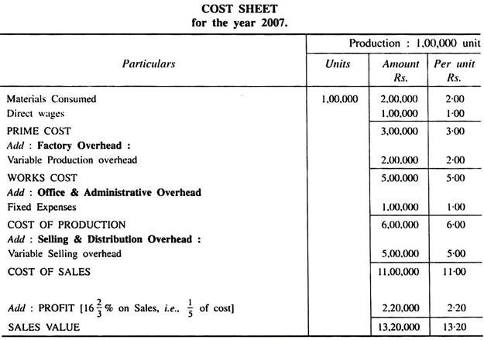
Working Notes:
(i) Variable overhead changed with production unit.
(ii) Fixed expenses assumed related with office and administration.

