Name of semester : 4th (IV)
Name of subject : CMA II
Name of teacher : ANUP GHOSH
Lecture No. O1

C-V-P Analysis and Marginal costing.
Cost-Volume-Profit analysis is the study of relationship among expenses(cost), revenue(sales) and net income(net profit). CVP Analysis may be applied for profit planning, cost control and management decision making.
There are some basic assumptions in making CVP analysis. They are:
i) Fixed cost i.e. periodic cost in total will remains constant.
ii) Selling price and variable cost per unit remains constant for a particular period of time.
iii) There should be only two types of cost i.e. fixed and variable if there is any semi-variable cost that should be segregated between fixed and variable first then we can apply the technique.
Now, Marginal costing is a technique which provides presentation of cost data in such a way that true cost-volume-profit relationship is revealed. Under this technique, it is presumed that costs can be divided in two categories i.e. fixed cost and variable cost. Fixed costs are charged to contribution of the period in which it is incurred and is considered as period cost.
CIMA London defines Marginal cost as " the cost of one unit of product or service which would be avoided if that unit is not produced or provided" i.e. additional cost for additional unit. Marginal cost is also known as variable cost or direct cost.
Marginal Costing, ICMA defines as " the accounting system in which variable costs are charged to the cost units and fixed costs of the period are written-off in full against the aggregate contribution. It has special value is in decision making".
Some of the assumptions required for applying CVP analysis and marginal costing are not realistic. In real world situation, all of them keep on changing, e. g. material cost will remain constant, but still CVP analysis and Marginal costing considered the most useful technique in management decision making. There are so many areas where top management has to take decisions e.g. Make or Buy, Problems on Limiting factors, fixation of minimum selling price specially in short term period, Shut down of production, exploring new market, accepting addition orders etc. Management can take correct decision only using marginal costing technique if they use other costing technique the decision to be proved wrong one.

Important terms in marginal costing:
i) Contribution - It is the amount that a concern can get after covering variable cost form sales value i.e. the amount to cover fixed cost and to earn profit if possible.
Contribution = sales-variable cost= fixed cost + profit= fixed cost - loss.
ii) Contribution per unit = Selling price - variable cost per unit
Or
Contribution per unit= change in profit / change in sales quantity
iii) Profit/volume ratio(P/V)= Any ratio indicate the relative position of two items e.g. Current ratio indicate the relative position of current assets and current liabilities . Similarly, P/V ratio implies the relative position of contribution and sales.
P/V ratio= contribution/ sales
Or
P/V ratio= change in profit / change in sales value
iv) Break even point(BEP): It indicates a level of activity i.e. sales or production at which there is neither any profit nor any loss. The firms' total sales value is equal to total cost. Mathematically, we can calculate break even point as follow-
BEP(in value)= Fixed cost/P/V ratio
BEP(in quantity)= Fixed cost/ contribution per unit
v) Margin of Safety(M/S): It indicates the level of safety at a particular point of activity. If a firm operates at break even point then it has no amount of safety because even the production or sales decreases by one unit then it will suffer loss. The greater the amount of present activity the greater the amount of safety it has or vice-versa.
M/S= Profit /P/V ratio
Or
M/S= Present sales - Sales at break even point
vi) Angle of incidence: It indicates the angle that is formed between two lines in a break even chart. The two lines are total sales line and total cost line. It can be better depicted in a break even chart given below.
v) For any level of activity we have:
Sales value =( Fixed cost+profit)/P/V ratio
Sales quantity =( Fixed cost+profit)/ contribution per unit
The above equations will help you to calculate any missing information.

BREAK EVEN CHART

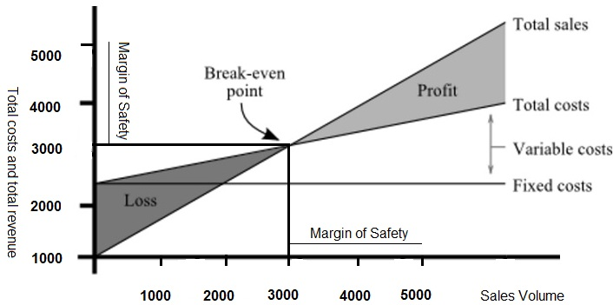

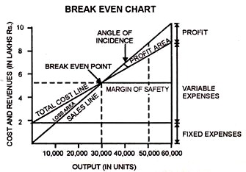
In the above two break even charts the above discussed terms are shown in a graphical manner.

Effects of the following changes on BEP, P/V ratio and M/S
( It will help you to have a clear idea about the above mentioned terms)
Changes in - BEP P/V ratio M/S
i) Increase in physical sales − − ↑
ii) Decrease in VC per unit ↓ ↑ ↑
iii) Increase in Selling price ↓ ↑ ↑
iv) Decrease in total fixed cost ↓ − ↑
v) Increase in raw material cost ↑ ↓ ↓
vi) Decrease in direct labour efficiency ↑ ↓ ↓
The above changes are mutually exclusive.
↓ indicate decrease, ↑ indicate increase, − indicate no effect.
In 6th case, decrease in direct labour efficiency will lead to lesser production by the direct labourer and result in increase in direct wages i.e. one of the variable cost.
In the lecture No. 02 I am to give you some problems .

