B. COM SEM – 6
Subject—Financial Management
Name of the Teacher: Prof. B. Chandra

CHAPTER NAME ----- WORKING CAPITAL MANAGEMENT -I
Discussion on the concept of working capital management (unit-4)

What is working capital?
Working capital is the difference between a company’s current assets and current liabilities. It is a financial measure, which calculates whether a company has enough liquid assets to pay its bills that will be due in a year. When a company has excess current assets, that amount can then be used to spend on its day-to-day operations.
Current assets, such as cash and equivalents inventory, accounts receivable and marketable securities, are resources a company owns that can be used up or converted into cash within a year.
Current liabilities are the amount of money a company owes such as accounts payable, short-term loans, and accrued expenses, which are due for payment within a year.
Positive vs negative working capital
Having positive working capital can be a good sign of the short-term financial health for a company because it has enough liquid assets remaining to pay off short-term bills and to internally finance the growth of their business. Without additional working capital, a company may have to borrow additional funds from a bank or turn to investors bankers to raise more money.
Negative working capital means assets aren’t being used effectively, and a company may face a liquidity crisis. Even if a company has a lot invested in fixed assets, it will face financial challenges if liabilities come due too soon. This will lead to more borrowing, late payments to creditors and suppliers and, as a result, a lower corporate credit rating for the company.
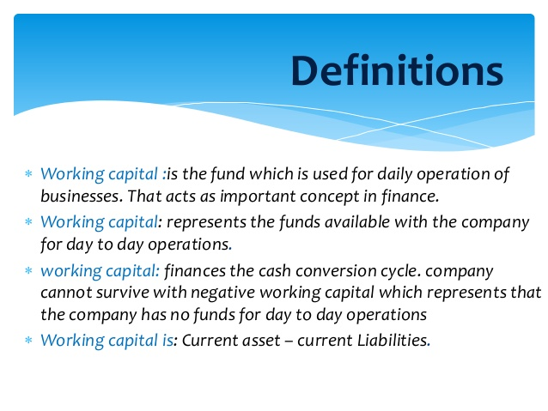

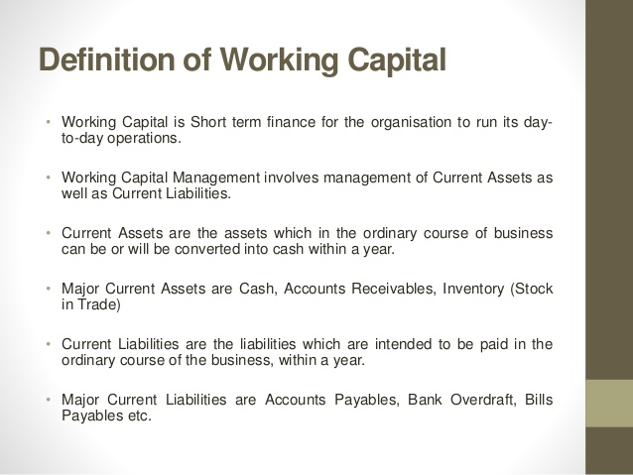

Types of working capital
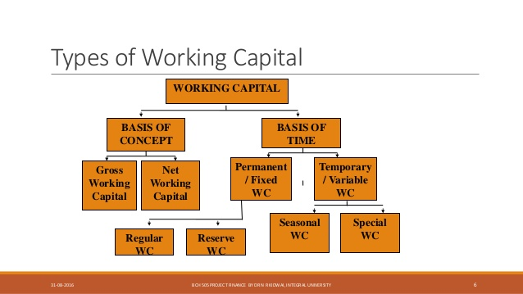
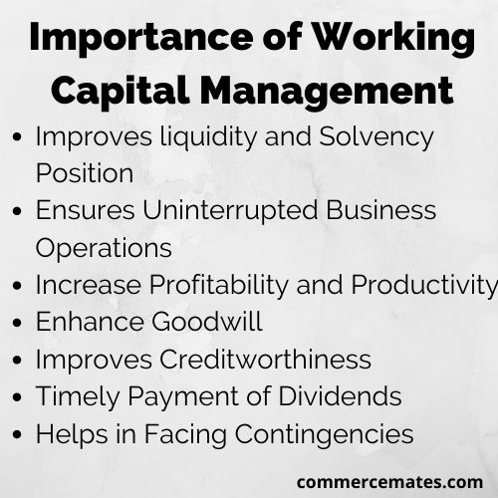
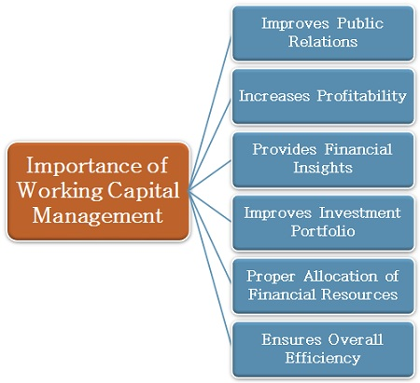

What is the Working Capital Formula?
The working capital formula is:
Working capital = Current Assets – Current Liabilities
The working capital formula tells us the short-term liquid assets remaining after short-term liabilities have been paid off. It is a measure of a company’s short-term liquidity and is important for performing financial analysis and managing cash flow. Below is an example balance sheet used to calculate working capital.

