UNIT 5: PROMOTION AND RECENT DEVELOPMENTS IN MARKETING: ADVERTISEMENT
Semester- II (UG)
Subject- Marketing Management
Topic-Advertisement
By- Dr. Sushita Chakraborty
Lecture no-1

“Advertising consists of all activities involved in presenting to a group a non-personal, oral or visual, openly sponsored identified message regarding a product, service, or idea. The message, called an advertisement, is disseminated through one or more media and is paid for by the identified sponsor”-William Stanton.
Philip Kotler:
“Advertising is any paid form of non-personal presentation and promotion of goods, services, or ideas by an identified sponsor.”
Types of Advertising:
Informative Advertising:
This is used heavily when introducing a new product category. In this case,the objective is to build primary demand.

Persuasive Advertising:

This type of advertisement becomes more important as competition increases.Here, the company’s objective is to build selective demand. Persuasive Advertising aims to create likings, preference, conviction and purchase of a product or service.Some Persuasive Advertising uses comparative advertising , which makes an explicit comparison of the attributes of two or more brands.
Reminder Advertising:
Reminder Advertising aims to stimulate repeat purchase of products and services. Reminder Advertising is important for mature products-it helps to maintain customer relationships and keep consumers thinking about the product.

Reinforcement Advertising:
Reinforcement Advertising aims to convince current purchasers that they made the right choice.
Features of Advertising:
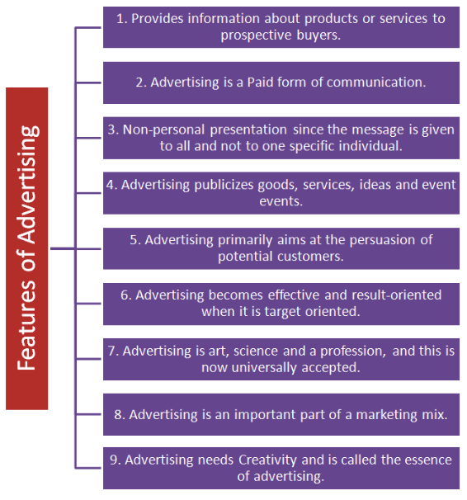
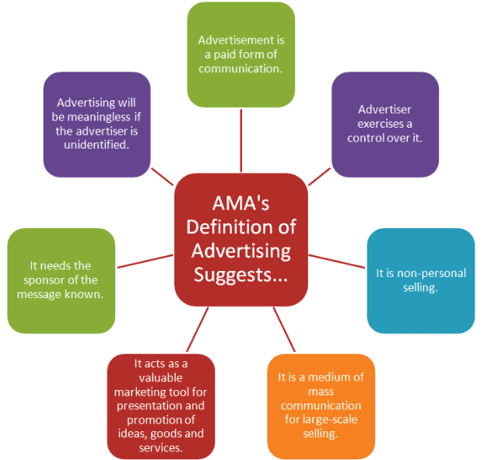
Advertising Objectives:
Advertising is aimed at achieving various objectives. Objectives may be commercial or social in nature. Prof. Kelly gave the concept of DAGMAR – Defining Advertising Goals for Measuring Advertising Results – in relation to advertising objectives. Broadly, advertising objectives can be categorized into three classes, such as informative objectives, persuasive objectives, and reminder objectives.
Prof. Sew and Prof. Smith have classified objectives as:
- Sales objectives
- Aiding sales force
- Competition-related objective
- Brand loyalty and reputation related objectives
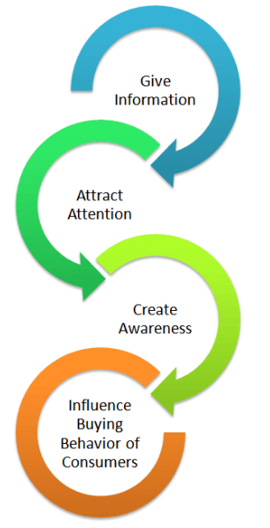
Developing and managing an advertisement program:
- Setting the advertisement objectives:
The overall advertising objective is to help in building customer relationships by communicating superior customer value.A specific communication task to be accomplished with a specific target audience during a specific period of time.
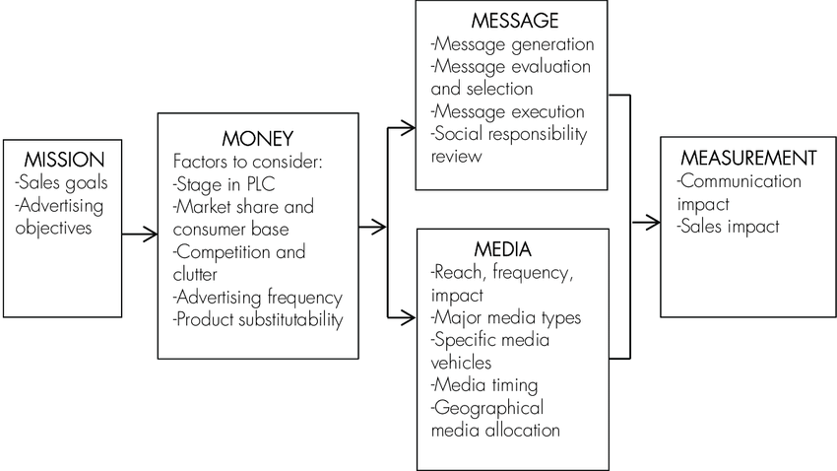
- Deciding on the advertising budget:
There are five specific factors to consider when setting the advertisement budget:
- Stage in the product life cycle(established brands have lower ratio
- Market share and consumer base(high share, less ratio)
- Competition and clutter(more competitors, more ad./sales ratio)
- Advertising frequency(The number of repetitions needed to put across the brand’s message to consumers has an important impact on the advertising budget.)
- Product substitutability(Brands in a commodity class require heavy advertising to establish a differential image. Advertising is also important when a brand can offer unique physical benefits or features.)

- Choosing the advertising message:
Advertiser go through 4 steps to develop a creative strategy i.e. Message Generation, Message Evaluation and selection, Message Execution, and Social Responsibility Review.
- Message generation: The message should be decided as part of developing the product concept. In generating advertising messages, agencies use inductive (talking to customers, dealers, experts & competitors) & deductive (buyers expect one of these types of reward from a product: rational, sensory, social or ego satisfaction).
- Message evaluation & selection: Dik Twedt suggested that messages be rated on desirability, exclusiveness & believability.
- Message execution: The message’s impact depends not only on what is said, but often more important, on how it is said. Some ads aim for rational positioning & others for emotional positioning. In preparing an ad campaign, a copy strategy statement should be prepared, describing the objective, content, support & tone of the desired ad.
- Social Responsibility Review: Advertisers and their agencies must be sure their “creative” advertising does not overstep social and legal norms. Most marketers work hard to communicate openly and honestly with consumers. Still, abuses occur, and public policy makers have developed a substantial body of laws and regulations to govern advertising.
- Deciding on media and measuring effectiveness:

- Deciding on reach, frequency, and impact Media Selection
Media Selection is finding the most cost-effective media to deliver the desired number of exposures to the target audience. The effect of exposures on audience awareness depends on the exposures’ reach frequency & impact.
Reach(R):The number of different persons or households exposed to a particular media schedule at least once during a specified time period.
Frequency(F):The number of times within the specified time period that an average person or household is exposed to the message.
Impact(I):The qualitative value of an exposure through a given medium.
Total number of exposures(E):E=R*F
Weighted number of exposures(WE):
WE=R*F*I.
Choosing among major media types:
Have to consider several variables like:
- Target-audience media habits
- Product characteristics
- Message characteristics
- Cost-(what counts is the cost-per-thousand exposures rather than the total cost). New media: Outdoor ad (excellent way to reach important local consumer segments), the store itself (displays & price tags supplemented by talking shelves), best-selling paperback books, movie theatres, movie videotapes, monthly bills, etc.

Allocating the Budget:
Selecting specific vehicles
The media planner must search for the most cost -effective vehicles within each chosen media type.
Media planners calculate the cost-per-thousand persons reached by a vehicle & rank them. Also need to consider: audience quality, audience attention probability & editorial quality.
- Audience size has several possible measures:
Circulation, Audience, Effective audience, Effective ad-exposed audience

- Deciding on media timing
In deciding which types of media to use, the advertiser faces both macro-scheduling problem ( involves scheduling the advertising in relation to seasons & the business-cycle) & micro-scheduling problem (calls for allocating advertising expenditures within a short period to obtain the maximum impact). Timing pattern should consider 3 factors: buyer turnover, purchase frequency & forgetting rate; the higher this rate, the more continuous the advertising should be.
- Deciding on geographical allocation
A company has to decide how to allocate its advertising budget over space as well as over time.

- Evaluating advertisement effectiveness.
Most of the money is spent by agencies on pre-testing ads, & much less on post-evaluating their effects. Better to first limit the campaign to one or a few cities, instead of nationally, to test the ad. In order to get the maximum yield, campaign effectiveness should be tested on the following parameters:
Brand Awareness
Knowledge about the brand
Preference for the brand
Sales effect

- Communication-effect research: Seeks to determine whether an ad is communicating effectively, also called copy testing. Pre-testing ad methods: direct rating (asks consumers to rate alternative ads), portfolio tests (ask consumers to view or listen to portfolio advertisements, taking as much time as they need) & laboratory tests (use equipment to measure consumers’ physiological reactions). Post-testing ads: To what extent did the ad increase brand awareness, brand comprehension, stated brand preference, & so on.

- Sales-effect research:
Harder to measure than communication effect. A way to measure it: share of market / share of voice; one is OK, less than one means they are overspending, more than one man’s money is spent super efficiently & should probably increase its expenditures. Researchers try to measure the sales impact through analyzing either historical (correlating past sales to past advertising expenditures using advanced statistical techniques) or experimental data (company spends more in some territories & less in others).

Reference-
- Gaurav Akrani- “Purpose, Features, Advantages, Role and 5M’s of advertising”(2010)
- Philip Kotler-“ Marketing Management”(2003, eleventh edition)
- Rajan Saxena-“Marketing Management”( 2009, Fourth edition)
- V S Ramaswamy and S Namakumari-“ Marketing Management -Planning, Implementation and Control”. ( 2009, Fourth edition).
- Philip Kotler, Gary Armstrong ,Prafulla Y. Agnihotri, Ehsan ul Haque, Kevin Lane Keller, Abraham Koshy, Mithileshwar Jha, “Marketing Management – for IMT, Ghaziabad”

